SLCSE Senior Environmental Outdoor Exploration Field Trip

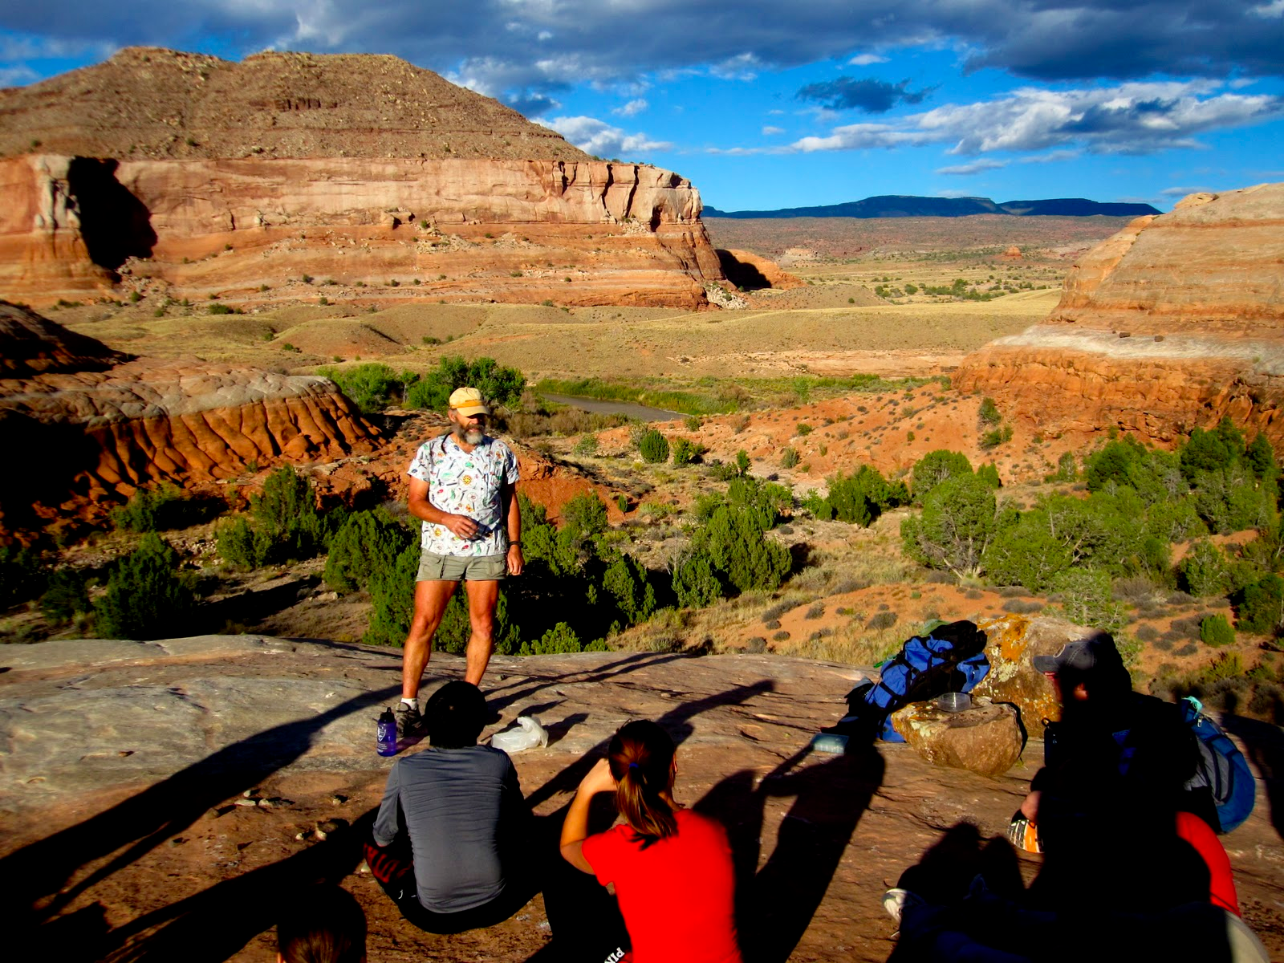
The SLCSE Mission Statement states that students will “develop the character and skills necessary to ‘Change Reality’.” Throughout your time at SLCSE, you have learned many things to help you “change reality”, including taking healthy risks, caring for your resources, and being curious and imaginative problem-solvers. This field trip celebrates your accomplishments of your high school career by providing an opportunity to experience first-hand many of the ideas developed during your time at SLCSE. On this field trip, you will deepen and enrich your appreciation and knowledge through:
- outdoor exploration activities that include rappelling, kayaking, backpacking, and hiking
- a community service partnership with Rio Mesa
- environmental science field experiences that include a naturalist hike, participation in a long-term ecological field experiment, and group discussions about human attitudes and impacts towards the environment.

When: Wednesday, May 6 – Saturday, May 9, 2015
Where: Rio Mesa Center (near Moab, Utah), riomesa.utah.edu
Who: SLCSE Seniors
Cost: $150 - $165 per student (costs will be adjusted based on # of participants)

Important preliminary information:
-Students will miss 3 days of school, and will be responsible to make up any missed work.
-Financial Aid is available to any student who wants to attend, but cannot cover the cost. Sponsors would be greatly appreciated.
-Parents/guardians are invited to participate as chaperones.
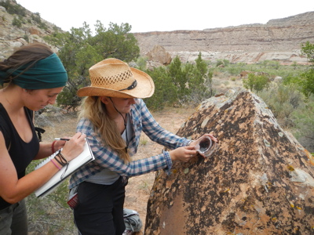
-Notable dates include the following:
* January 23 - informational flyer response form due
* March 26, 3:30 – senior meeting
* April 9 – money due
* April 23-24 – training camp
* April 23, 6:30 p.m. – parent meeting and dinner

Name of Student ____________________________________________________
Parent’s Name(s) __________________________________ Contact Info _________________________
__________________________________ _________________________
Interested in financial aid Yes No
Interested in sponsoring a student Yes No
Interested in being chaperone Yes No
Able to attend meeting on 1/21 Yes No

Parent Signature _________________________________ Student Signature ___________________________
Response requested by January 23, 2015.
Please feel free contact Ms. Moretz or Mr. Eaton with any questions, elizabeth.moretz@slcschools.org and cavett.eaton@slcschools.org, respectively.

Purpose:
This trip is designed to give students a meaningful outdoor and field science senior experience. Students will camp, cook, hike, write, collect data, and share discoveries with their peers.

Sample Itinerary:
Location: Rio Mesa Center, located about 45 minutes from Moab, UT
TENTATIVE Schedule:
Leave 8:00 am, Wednesday, May 6, 2015
Stop in Spanish Fork to learn about wind energy. Picnic lunch at rest area. Arrive at Rio Mesa early afternoon. Set up camp. Naturalist hike into Bridge Canyon. Dinner. Reflection and optional stargazing. Retire.
Thursday, May 7, 2015
Early morning nature watch. Breakfast. Rappelling and naturalist hike with scientist(s). Lunch. Field ecology collection experience. Reflection and group reports on first day at field station. Dinner. Light pollution talk and optional stargazing or evening hike.
Friday, May 8, 2015
Early morning nature watch. Breakfast. Kayaking and river ecology/water issues activity. Lunch. Field ecology collection experience. Reflection and group reports on first day at field station. Dinner.
Saturday, May 9, 2015
Early morning nature watch. Breakfast. Break camp and clean. Final discussion and group reports. Travel back to Salt Lake City, Arrive by 5:00pm.

