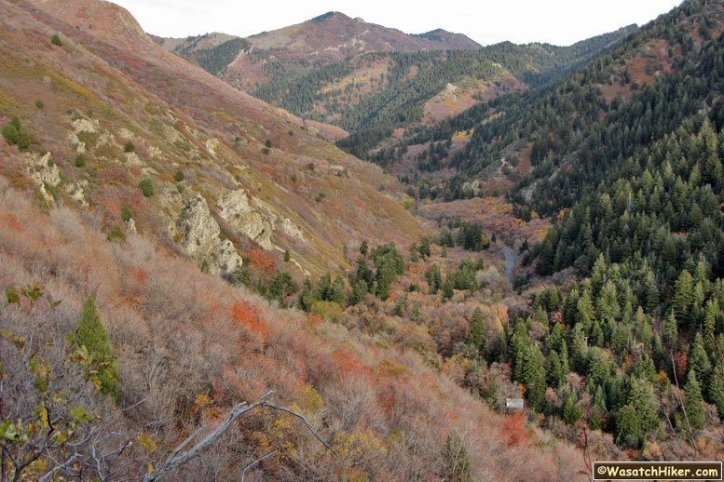

Itinerary

- 8:30 – Depart SLCSE
- 9:00 – Arrive at Millcreek Canyon, Box Elder campground
- 9:00 – 9:15 – Field investigation description, Moretz
- 9:15 – 9:30 – Using statistics for designing field experiments, Chandler
- 9:30 – 10:00 – Designing an appropriate sampling protocol, AP Stats/APES
- 10:00 – 11:45 – Field ecology experiment and hiking
- 11:50 – 12:30 – Preliminary statistical analysis, Chandler
- 12:30 – 1:15 – Cookout lunch
- 1:15 – 1:30– Connecting the data to the research question, Moretz
- 1:30 – Depart Millcreek Canyon
- 2:00 – Arrive at SLCSE

Location, Millcreek Canyon

Millcreek Canyon is a canyon in the Wasatch mountains, located between Big Cottonwood Canyon and Parley’s Canyon. It is densely forested, contains numerous alpine meadows, and an 18. 5 mile creek flowing through the canyon.
One moderately trafficked road ascends the canyon, with road closures at higher elevations during occurring in winter months. The area is used primarily for recreational purposes. It is a popular site for mountain biking, hiking, and cross-country skiing. Dogs are permitted in the canyon. Dog waste and human activities have contributed to substantial habitat and water quality degradation in the past. The land is managed by the U.S. Forest Service.

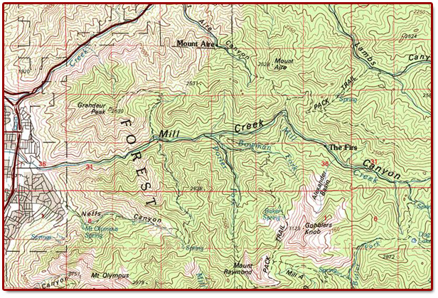

Field Site, Desolation Trail
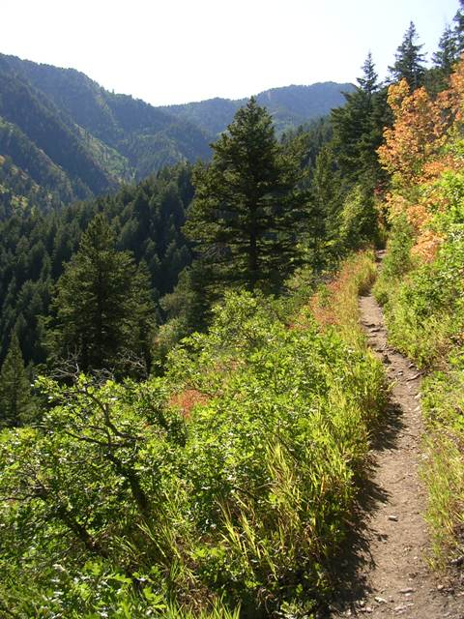
Desolation Trail is a well maintained path in the Olympic Wilderness area. The trail climbs out of Mill Canyon on a series of relatively easy switchbacks reaching, in less than two miles, an overlook of the city. From there it meanders up a canyon to a small saddle. Rest here because a long series of switchbacks lie between the saddle and the next pass. From the pass, the hike runs up and down on its way to Dog Lake just outside the eastern boundary of the wilderness. Unlike most mountain lakes, Dog Lake lies in the middle of a forested area instead of a cirque. From Dog Lake it is fairly easy going to Desolation Lake. Desolation Lake sits in a picturesque mountain cirque and serves as a perfect terminus to a long hike. From Desolation, you can retrace your steps to the vehicle, or choose a couple of shorter trails that lead south into Big Cottonwood Canyon and, if you've thought ahead, a second vehicle.

Lab Investigation, The Effect of Edge Habitat on Ecosystem Health

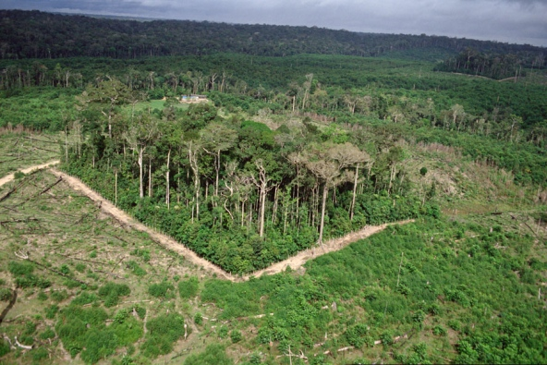
Introduction
As humans interact with the landscape, habitat loss and/or fragmentation is of increasing concern. Habitat fragmentation occurs when a larger, continuous environment is broken into smaller remnants. This may be caused urban development, commercial forestry, mining, agriculture, and other anthropogenic (human) activities. Natural processes such as wildfire and tornado may also fragment habitat.
When a landscape is divided, the edge habitat increases in area, while the interior environment decreases. Edge and interior habitats vary in their abiotic conditions, as the edge environment has higher light levels, higher temperatures, and lower soil moisture levels. As a result, the health of an ecosystem is often compromised when habitat fragmentation occurs. Specifically, habitat fragmentation causes a decline in biodiversity and population density, change in species composition and interactions, disruption to ecosystem functions, and an increase in invasive species and land-use activities. These changes may result in the ecosystem having less variety of food, breeding grounds, and shelter for a range of organisms. It may also result in the ecosystem being more prone to disturbance and less resilient to changes in the environment, leading to even greater change in the future.

Study Site
A comparison of edge and interior habitat plant species will take place at Desolation Trail in Millcreek Canyon and compared with species composition found along the Skyline Trail at Red Butte Canyon. Millcreek Canyon and Desolation Trail are described above. Red Butte Canyon is an area that is heavily used by hikers, runners, mountain bikers, and dog walkers. Two main regions have been identified: the area adjacent to the dirt road and the area along the Skyline Trail immediately to the South of the dirt road (Figure 1). The region along the dirt road is considered edge habitat because the road clearly breaks the tree canopy and separates the dominant vegetation into smaller pieces. Light levels and temperatures are noticeably greater in this area. The area off of the Skyline Trail is considered interior habitat because it is away from the edge created by the dirt road, has an intact canopy, and maintains a relatively continues environment. While the trail does separate the habitat slightly, the effects are thought to be minimal.

Student Objectives:
- Gather evidence to support/refute the ecological theory that increased fragmentation will negatively impact the ecosystem health.
- Use evidence gathered in study to explain the importance of biodiversity as it effects ecosystem interactions and health.
- Apply information learned from this study to make inferences of how future land-use patterns may impact ecosystem.

Line Transect Sampling Technique
Vegetation surveys will be conducted using a line-transect method. This is a tool used to determine the type and abundance of plant species in a given area. It allows scientist to consider small understory species and larger saplings, shrubs, and trees. In this method, the measuring “tape” is extended through the randomly selected area. The type and abundance of each plant species through which the tape crosses is recorded. This includes plants crossing above and below the measuring tape.

Procedure:
- Randomly assign locations for line transects. Student determined
- Place transect
  - Begin transect at the NW corner of the randomly determined location.
  - Extend transect 10 m perpendicular to the edge.
  - Transect should be relatively strait. If a large object (e.g., tree) is in the path, place transect at its base, go around, and continue in approximately a straight line.
  - Secure tape by placing “nail” in soil
- Determine type and abundance of plant species
  - At each 0.25 m along transect, note the type of plant that is directly below or above the tape. (Note: the canopy of a tree may cross above the tape even though its trunk may not. This should be included in data collection.)
  - Type of plant should be recorded by specific plant name (e.g., Gambler oak, canyon maple, cheat grass) if it is known OR by generic name (plant A, plant B, plant C, etc.). Each plant species should be given a unique plant name.
  - Record the number of times each plant type is observed at each 0.25 m along transect.

Data Collection Student determined

Analysis
- Calculate species diversity using Shannon Weiner Diversity Index
  - Formula:
    - H = -SUM[(pi) * ln(pi)]
    - Where, SUM = Summation pi= Number of individuals of species i/total number of samples S = Number of species or species richness
    - Results range from 1 to 4, with 4 having the greater diversity
- Calculate species evenness
  - Formula:
    - E=H/H_{max}
    - Where H_{max} = Maximum diversity possible
    - Results range from 0 to 1, with 1 having perfect evenness
- Additional analysis – student determined

Discussion
- Compare diversity and evenness between edge samples and interior samples.
- Compare percent invasive species between edge samples and interior samples.
- Explain the effect of edge habitat on species diversity.
- Discuss how edge habitat affects ecosystem diversity.
- Edge habitat species profile … link to food web dynamics…
- Considering the information learned regarding the relationship between edge habitat and ecosystem health, what recommendations can be made to land managers to promote a more sustainable ecosystem?
- Describe the “next steps” to be taken to further investigate this subject?

Reflection
- Consider today’s research experience. What went well? What would you do different in the future?

Experimental Design

Include the following in your experimental design:
- Independent variable
- Dependent variable
- Control
- Constants
- Trials
- Experimental treatments
- Sketch of procedure

Random Sampling
There are many ways of choosing where to take our data:
 | Simple Random Sampling | Stratified Sampling | Cluster Sampling
Definition | Each individual is chosen from the population randomly and entirely by chance. | Partition the population into groups based on a factor that may influence the variable being measured, then randomly select the same number of individuals from each subgroup. | Partition the population into subgroups, then randomly choose a set number of subgroups and gather data from every member in the chosen subgroups.
Example | Mrs. Chandler pulls 5 names out of a hat (to do her evil bidding). | Mrs. Chandler divides the students into a male group and a female. She then chooses 3 boys and 3 girls randomly (to do her evil bidding). | Mrs. Chandler lines up 32 students based on birth month and day and divides them into groups of 4 based on where they are in line. She then chooses (randomly of course) three of the 8 groups (to do her evil bidding).
Explain What This Sampling Method Would Look Like For Us (Please use a drawing in your explanation)
Which sampling method would be best for our situation? Why?

Data Collection

Data Collection

Meta Data:

Temperature ____________________________ Precipitation ____________________________

Cloud Cover ____________________________ Elevation ____________________________

Other ( ) ____________________________ Other ( )____________________________

Preliminary Data Analysis

Introduction: When analyzing data, keep in mind the central question(s) the study is investigating. In the case of this lab, the experiment is examining the relationship between disturbance and a population of myrtle spurge. This was assessed by gathering data on 1) the percent of myrtle spurge cover and 2) the number of different species present in the sampled area. All data analysis should offer quantitative support to determining if in fact the disturbance did have an effect on myrtle spurge.
Pre-Data Analysis:
- Review your hypothesis.

Hypothesis:

- Identify the data collected in the experiment.

- Identify what results you would need to see in your data to support your hypothesis (if _____________ is shown in the data, then the hypothesis is correct because _____________).

- Sketch out rough graphs that would illustrate the data that would support your hypothesis. The graphs should correspond to the points identified in pre-analysis step #3.

Preliminary Conclusions

