Trump’s Wall May Threaten Thousands of Plant and Animal Species on the U.S.–Mexico Border

The region—called the Sky Islands—harbors more than 7,000 species, many of which struggle to cross human-made obstructions

* By [Cally Carswell](https://www.scientificamerican.com/author/cally-carswell/) on May 10, 2017

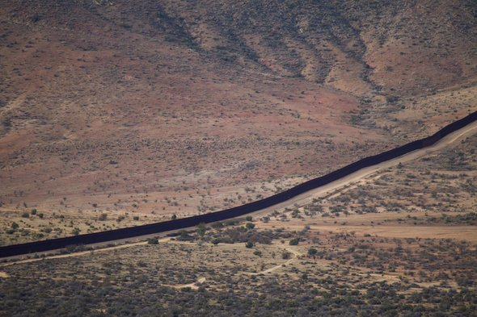

After nightfall last November 16 a sleek and rare wild cat sauntered past a remote camera in the Dos Cabezas Mountains east of Tucson, Ariz. The animal triggered a motion sensor and a camera flash popped. Frozen in stride halfway through the frame was a jaguar, its pointy black ears splotched with yellow. Federal wildlife officials later scrutinized the image their camera caught, comparing the animal’s markings with jaguars spotted elsewhere in Arizona in recent years. No match—this was a new migrant.

It was only the third known jaguar to wander into Arizona from Mexico since 2012, and perhaps the sixth since the big cats were extirpated from the U.S. in the 1960s. For conservationists, the prospect of a beautiful jungle cat recolonizing our southern deserts is pure romance. A jaguar that prowled the Santa Rita Mountains became something of a local folk hero. Known as El Jefe, last spring a mariachi band played at the unveiling of a downtown Tucson mural in the feline's likeness. “*Viva!*” the crowd cheered.

But for the cats, there is no romance—at least not yet. So far, only males have ventured into Arizona, likely searching for territory and mates after dispersing from a breeding population about 130 miles south of the border in Mexico. Females generally don’t travel so far looking for love, though. Whether jaguars gain a real foothold in the U.S. may then depend on a slow northward expansion of the Mexican population.

That expansion would depend on narrow corridors of mountain habitat that run north–south along the border and serve as the cats' conduits between the two countries. And now a new threat has emerged: Pres. Donald Trump’s plan to fortify the length of the U.S–Mexico border with his “big, beautiful wall.” The human migrants Trump wants to keep out can climb walls or tunnel under them. They already do both in areas the George W. Bush administration fenced after the 9/11 attacks. Jaguars and numerous other species, however, can’t or won’t surmount tall, solid barriers. “In wild settings people are really the only species we know is definitely going to get over the wall or under it,” says Aaron Flesch, a wildlife biologist at the University of Arizona.

A new wall, in other words, would be a symbolic affront against illegal immigration. But it could have long-term consequences for the ecological life of the U.S. and Mexico borderlands.

**A SURPRISING EDEN**

Many Americans imagine the border as a dry, punishing wasteland—if they think of it at all. Yet where New Mexico and Arizona meet Mexico sits one of the largest protected landscapes in North America outside of Alaska and northern Canada. It’s an intersection of deserts and mountains, along with temperate and subtropical climates.

The region includes the Sky Islands, named for the isolated mountain ranges that rise from the flats of the Chihuahuan and Sonoran deserts—an inland archipelago that sits primarily in Mexico but spills over the border. The mountains are wetter than the surrounding region, with vegetation that changes with elevation. Shrubs and cacti give way to oak, juniper and pine, and at the very top, even spruce and fir. Large mammals like black bears, mountain lions and bighorn sheep live in these mountains, along with a flabbergasting number of birds. More than 7,000 plant and animal species make their homes here, and more than half of the bird species found on the entire continent inhabit the Sky Islands.

Although the region itself is vast, good habitat can be scarce. Water is the limiting factor and its availability is unpredictable. Many streams run only intermittently and rain tends to fall in quick bursts from isolated thunderheads, wetting one mountain range or section of desert grassland while the surrounding landscape dries out. To find food and water, animals need freedom to move. “They’re constantly following the rain patterns,” explains Scott Wilbor, conservation science director for the Sky Islands Alliance, a Tucson-based group.

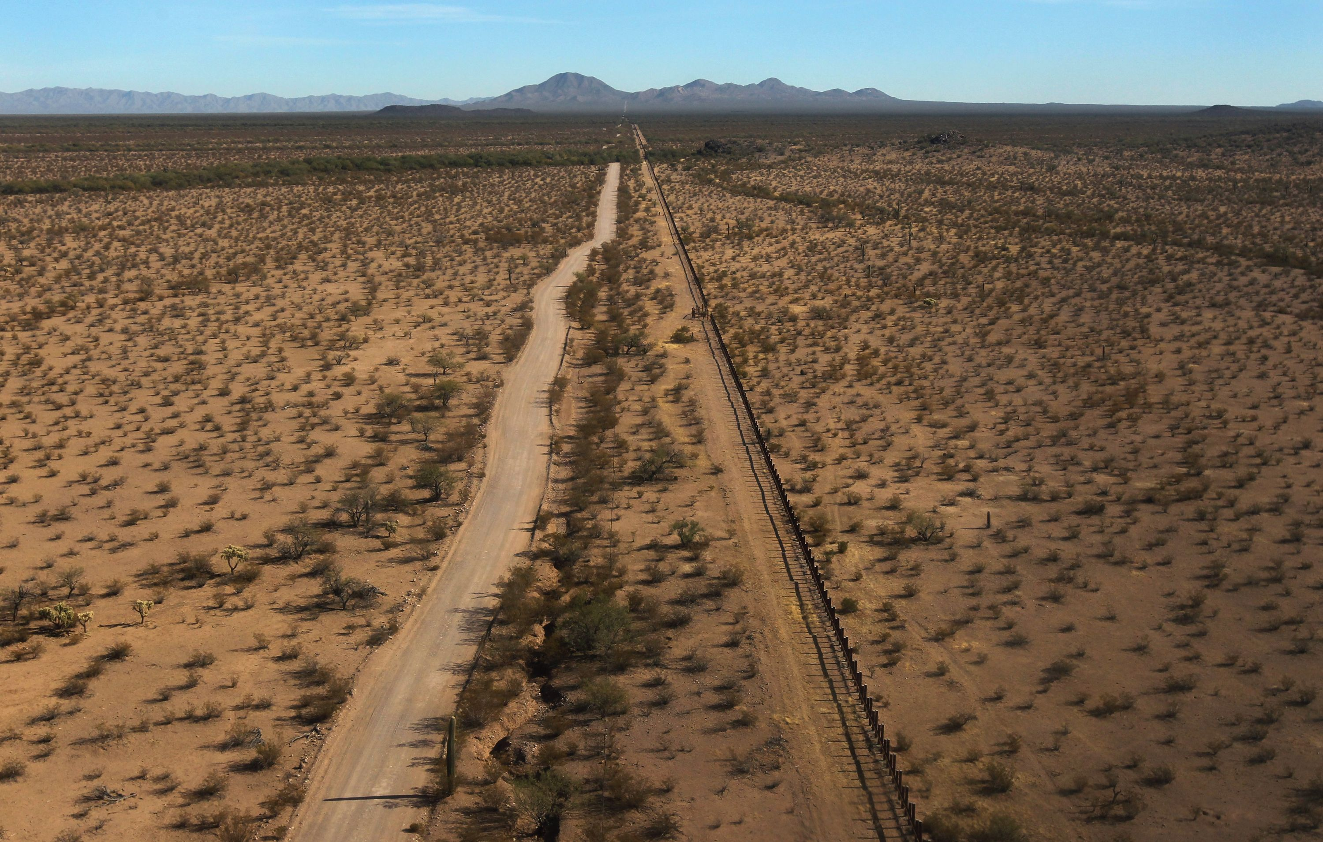

That freedom is already restricted by steel border fences—roughly 35 percent of the entire U.S.–Mexico boundary has been fenced. In 2005 Congress passed a law called the REAL ID Act, which granted the secretary of Homeland Security authority to waive local, state and federal laws that might slow the construction of national security infrastructure on the U.S.–Mexico border. Those laws include the Endangered Species Act, the Migratory Bird Treaty Act and the Wilderness Act, which might otherwise slow or delay construction within vulnerable habitats.

After Congress passed the Secure Fence Act of 2006, calling for 700 miles of new border barriers, former Homeland Security Secretary Michael Chertoff summoned his REAL ID powers to fence the banks of the San Pedro River in southeastern Arizona and the U.S. Air Force’s Barry M. Goldwater Range to the west, among other places. Today 318 miles of Arizona’s 378-mile-long southern border are blocked with some sort of security barrier. And officials have cut thousands of miles of new patrol roads through formerly wild landscapes, including federally protected wilderness areas, national monuments and wildlife refuges.

**BARRIER IMPACTS**

Generally speaking, barriers to movement are bad for wildlife. “Connectivity is really essential, and we know that species that have certain traits are going to be negatively affected,” Flesch says. But just how much different animals have been impacted by development on the border isn't well understood. To rank the relative risks animals face would require extensive studies on where the habitat is for various species, the quality of that habitat, how animals move between patches of habitat and whether they can penetrate existing barriers, he explains. There are breaks in the fencing, for instance, and some spots are blocked only by barriers intended to stop vehicles—single horizontal bars welded to widely spaced steel posts—under or over which most animals can slip or jump.

One of the exceptions is the endangered Sonoran pronghorn, which is highly sensitive to human activity, roads and fencing of any kind. Although pronghorn can scoot under vehicle barriers, they seem to avoid doing so, says University of Arizona wildlife ecologist Dave Christianson. The ability of pronghorn to move freely between the U.S. and Mexico is probably already gone, he says, thanks to a highway on the Mexican side and U.S. border fencing. He thinks they probably still have enough room to roam in the U.S. to persist here but may always need a helping hand from federal wildlife officials, who are breeding the animals in captivity to rebuild the population, which struggled even before border security intensified.

Other species likely to be vulnerable to border barriers include bighorn sheep, ferruginous pygmy owls and black bears. Genetic research on black bears has shown populations in southern Arizona are more closely related to bears in Mexico than those in northern Arizona. Because their populations are already small in the region, barriers that isolate bears could eventually lead to inbreeding, increasing the risk of local extinction over time.

ADVERTISEMENT

Similarly, a 2009 study by Flesch showed a significant amount of gene flow between desert bighorn sheep populations in the U.S. and Mexico. It suggested an impermeable border barrier would disrupt this network, severing important corridors in Organ Pipe National Monument and Cabeza Prieta National Wildlife Refuge. “They might not be harmed north of the border in places where there’s a lot of habitat,” he says. “But in Sonora there are lots of little populations.” If those small populations blinked out, as they sometimes do, border barriers could prevent U.S. sheep from repopulating the habitat in Mexico.

Even birds can be affected. Flesch found pygmy owls rarely took flight at heights lofty enough to clear border fences and avoided large gaps in vegetation, which are common near the barriers. In this case, maintaining connectivity should help owls persist in Arizona, where they are more imperiled than in Mexico.

The same is true for jaguars. The U.S. Fish and Wildlife Service is working on finalizing a recovery plan for the endangered cats, and its current plan is to focus conservation efforts on the population in Sonora, estimated at just under 300 animals. At this point, the cats are functionally extinct in the U.S. An unbroken wall would seal their fate. “It would basically give us no avenue for recovery," Flesch says.

**PASSABLE CORRIDORS**

Although the national security apparatus has already transformed much of the U.S.–Mexico border, Trump’s wall could deal a blow to wildlife if it severed key corridors that until now have remained open and passable.

One of these is a small wildlife refuge in southeastern Arizona called San Bernardino, says Dan Millis, who program managerthe Sierra Club’s Borderlands campaign. The Rio Yaqui flows south from the refuge into Mexico and supports a number of endangered fish. Millis says the U.S. Fish and Wildlife Service has successfully worked with the U.S. Border Patrol to prevent the river corridor from being fenced, and to minimize traffic in the refuge.

Sky Island Alliance’s Wilbor says there are also a few rugged mountain ranges, like the Baboquivari and Patagonia , that bisect the border where there’s either no fencing, a few strings of barbed wire or vehicle barriers. “That’s still very permeable for wildlife,” he says. These are likely the corridors jaguars slipped through and are important habitat for numerous other species. A total of 49 mountainous miles remain free of any kind of border barrier in the Sky Island region, with about half of that in a single mountain range, according to a calculation provided by the Alliance.

Protecting these places will become even more important in the future, as the climate changes, experts say. “We’re already experiencing hotter temperatures, a shorter monsoon season, drier winters,” Wilbor says. The public lands that dominate the border from Yuma, Ariz., through the boot heel of southwestern New Mexico present an opportunity to implement management solutions at a large scale to help species adapt to shifting conditions. “We have a lot of capacity on our U.S. public lands to implement adaptation strategies,” he says, including restoring streams and seeps, and harvesting rainwater. “But we need cross-border connectivity so these species can have their full range.”