CELL MEMBRANE NOTES NAME___________________________
PERIOD__________________________
DATE____________________________
The cell membrane can also be known as what?

What are four functions of the cell membrane?
1.
2.
3.
4.
Where can the cell membrane be located?

In what type of cells can a cell membrane be found?
What are the two main things that the cell membrane is made of?
1.
2.

Phospholipids are made up of…
Two ___________ ___________ and a ________________ group.

Fatty Acids are ________ polar and are hydro______________.

The Phosphate group is ______________ and hydro__________________.

Hydrophobic means _______________________________________________.

Hydrophilic mean_________________________________________________.

Why is the phospholipid referred to as a bilayer?

Why is the cell membrane a semi-permeable membrane?

What are some examples of things that need to be able to get into or out of the cell membrane?

For molecules that cannot directly pass through the cell membrane, how do they cross the cell membrane?

What are two places proteins can be found around the cell membrane?
1.
2.
What are three functions of these membrane proteins and the name of the associated protein?
1.
(_____________________ proteins)

2.
(_____________________ proteins)

3.
(_____________________ proteins)

What role do carbohydrates serve at the cell membrane?

Where can they be found?

Why is the cell membrane referred to as Fluid Mosaic?

Fluid:

Mosaic:

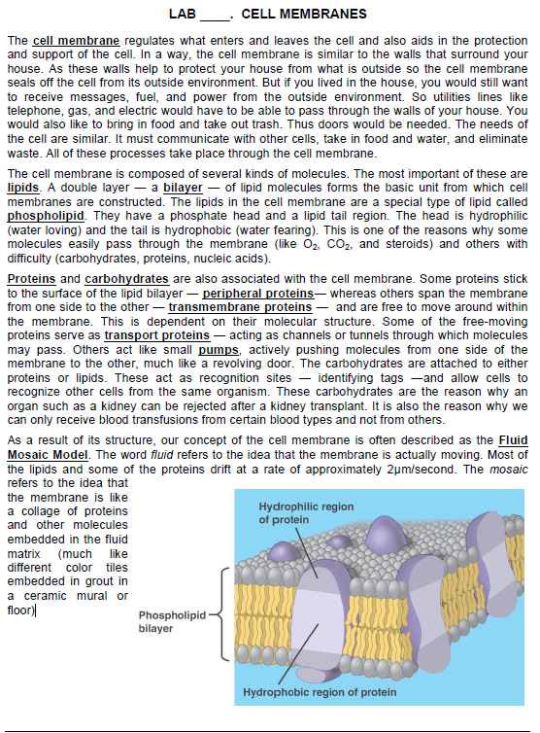
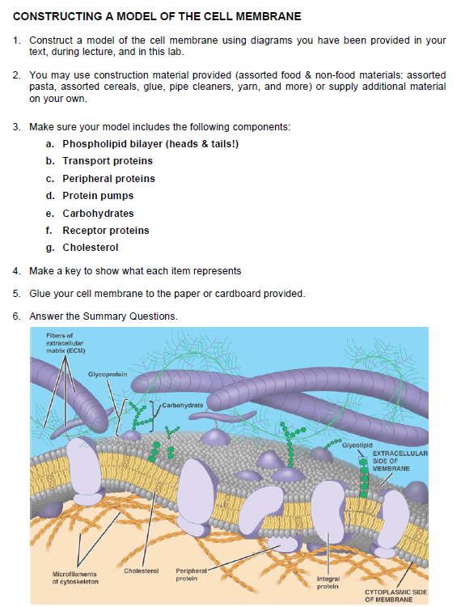
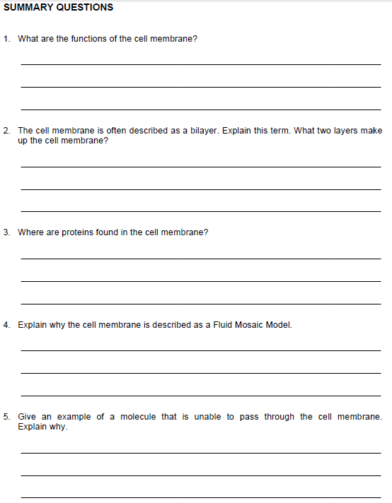
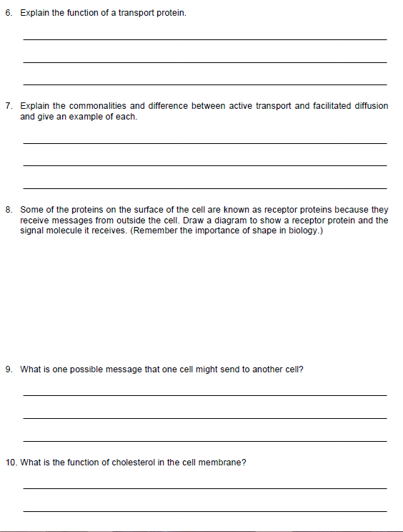
What vocabulary word represents one of the cell membranes important functions?

What does this word mean concerning the cell membrane?
We have discussed a semi-permeable membrane, but what is a selectively-permeable membrane?

What analogy is helpful in remembering this?
What are the two parts of a concentration gradient?
1.
2.
What are the two types of transport across a gradient?
1.
2.
What type of movement across a gradient goes WITH the gradient?

This is movement from a ___________ concentration to a _____________ concentration.

What are the two types of transport that fall under this type of movement?
1.
2.
How much energy is required for this type of movement?

Write a definition for Diffusion.

What state do molecules want to be at in nature?
Draw a sketch of diffusion taking place. Be sure to indicate high and low concentrations and movement across a membrane.

What is the difference between diffusion and facilitated diffusion?

What do they both have in common?

What proteins are associated with facilitated diffusion?

If osmosis is still diffusion, what molecule is specifically involved in osmosis?

Draw a sketch of osmosis taking place. Remember to label concentrations and molecules.

Write in a definition for the following osmosis terms;  Isotonic-  Hypertonic-  Hypotonic- | Sketch to illustrate term
What is the importance of osmosis?

What type of cell would do well in an isotonic state of osmosis?

What type of state of osmosis would an animal cell do best in? Why?

What is a possible outcome of the following cell becoming more and more hypotonic?
Animal-
Plant-
What structural benefit does a plant cell have over an animal cell concerning osmosis?
Passive Transport Review:
Diffusion
- Move from ___________ to ____________ concentration.
- Goes ______________ through the _________________.
- _______ energy required.
Facilitated diffusion
- Molecules are helped through a ______________ ______________.
- _______ energy required.

Active Transport: Write a definition for active transport.

In active transport the molecules from a concentration that is….

What is required in active transport that is not in passive transport?

What proteins are associated with active transport?

Draw a sketch of Passive Transport (diffusion and facilitated diffusion) and Active Transport.

Endocytosis
Write a definition, in your own words, for endocytosis.

What cellular organelle is formed from this process?

What is an example of this type of process in the human body?

Exocytosis
Write a definition, in your own words, for exocytosis.

What happens to the vesicle involved this process?

What is an example of this type of process in the human body?

Draw a diagram illustrating the process of Endocytosis and Exocytosis.

Endocytosis Exocytosis

