Cell Quiz Moretz
Biology 2019/2020

- The primary function of the cell membrane is to
A regulate what materials may enter and/or exit the cell.
B speed up chemical reactions.
C move the cell from one location to another.
D transport and package proteins.

- The large organelle needed to store water and add structure to a plant cell is a
A cell wall
B nucleus
C ribosome
D vacuole

- All of the following statements are true except
A cells are self-replicating.
B every living organism is made up of at least one cell.
C every living organism contains cells with a nucleus.
D cells may be an organism or a specialized part of an organism.

- Which type of cell best describes all bacteria?
A animal cell
B plant cell
C eukaryote
D prokaryote

- A cell that is lacking a well-defined nucleus and membrane bound organelles is a
A animal cell
B plant cell
C eukaryote
D prokaryote

- Which of the following sequences most accurately describes the production and movement of proteins through the cell
A Golgi apparatus, ribosome, endoplasmic reticulum, nucleus
B nucleus, ribosome, endoplasmic reticulum, Golgi apparatus
C nucleus, endoplasmic reticulum, ribosome, Golgi apparatus
D nucleus, mitochondria, centriole, ribosome

- Which of the following best explains the difference between plant and animal cells?
A Animal cells contain a nucleus and plant cells do not.
B Plant cells contain membrane bound organelles and animal cells do not.
C Animal cells contain mitochondria and a cell membrane; plant cells do not.
D Plant cells contain chloroplast and a cell wall; animal cells do not.

- Which structures are found in ALL cells?
A cell wall, cytoplasm, nucleus, & proteins.
B cell wall, cytoplasm, DNA, & ribosomes.
C cell membrane, cytoplasm, DNA, & ribosomes.
D cell membrane, cytoplasm, nucleus, & flagella.

- A scientist observes a cell with a microscope. She observes a cell wall surrounding a nucleus, mitochondria, ribosomes, and chloroplast. What type of cell is the scientist observing?
A animal cell
B plant cell
C prokaryote
D bacteria

- Which statement best describes a ribosome?
A Structure found in the cytoplasm of all cells and is needed for assembling
proteins.
B Structure found in the nucleus of all cells and is needed for assembling
DNA.
C Structure found in the nucleus of prokaryotes and is needed for storing
nutrients.
D Structure found in the cytoplasm of all cells and is needed for digesting
nutrients.

- The cell theory states
- All cells come from pre-existing cells
- All cells contain a nucleus
- Cells are the basic unit of structure
- All living organisms are made of 1 or more cells.

A I, II, & III
B II, III, & IV
C I, III, & IV
D I, II, & IV

- Root hairs (cells along the exterior lower part of roots) have a thin, elongated shape. One advantage of this is
A the shape increases the volume of the cell, allowing for more efficient water absorption
B the shape decreases the volume of the cell, preventing toxic chemicals in the environment from entering the cell.
C the shape increases the surface area to volume ration, allowing for more efficient water absorption
D the shape helps protect the root from herbivores

- Epithelial cells are cells that line the small intestine. They have numerous cilia on their exterior. One advantage of this is
A the cilia move nutrients along the digestive tract, allowing for more efficient water absorption
B the cilia move the cells from one place to another
C the cilia allows for more efficient waste removal
D the cilia serve no function for this cell type

Refer to the diagrams below to answer the next 6 questions.
H
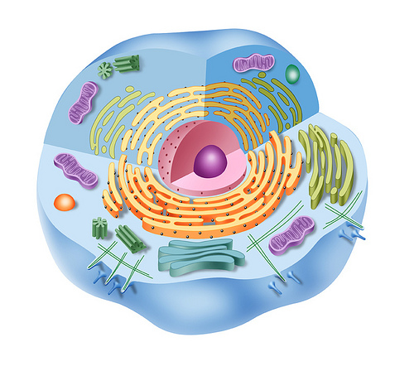
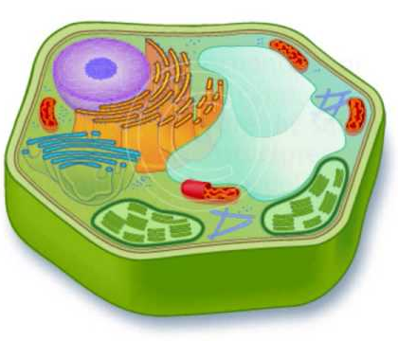

D

F
C

E
Cell 2
A
Cell 1
B
G
Cell 3

K

J

I

L

- Cell 1 can best be categorized as a
- Eukaryote
- Prokaryote
- Plant cell
- Animal cell

- The organelle that is responsible for cell movement is represented by
- letter G
- letter H
- letter I
- letter J

- The organelle that stores water and nutrients in all eukaryotes but also provides structure in a plant cell is represented by
A. letter E
B. letter F
C. letter G
D. letter H

- The organelle that is responsible for digesting food molecules and worn out cell parts is represented by
- letter A
- letter B
- letter C
- letter D

- The organelle that is responsible for providing structure and support to the cell is represented by
- letter H
- letter E
- letter L
- letter K

- The organelle that is responsible for packaging, labeling and shipping proteins is represented by
- letter A
- letter B
- letter C
- letter D

- If a cell needs to go someplace, I’m the one you’re looking for. Who am I?
- nucleus
- mitochondria
- chloroplast
- flagella

- I am found in the cytoplasm of all eukaryotes. I convert glucose into ATP. Who am I?
A vacuole
B mitochondria
C centriole
D lysosome

- I contain chlorophyll to capture solar radiation that I then turn into glucose. My best bud is the mitochondria. Who am I?
A chloroplast
B chlorophyll
C cell membrane
D cytoplasm

- I think I am the most important part of the cell. I contain all of the genetic instructions needed for life. I am surrounded by a special membrane to control what enters and exists. You will not find me in a prokaryote. Who am I?
A nucleus
B cell membrane
C mitochondria
D ribosome

- I am found in all cells. I keep things together, literally. But, if something shouldn’t come into the cell, I keep it out. Who am I?
A cytoplasm
B cell wall
C chloroplast
D cell membrane

The following diagram will be used to answer the next 3 questions.

- This diagram depicts a
A carbohydrate
B enzyme
A
C phospholipid
D glycerol

- In this diagram, “A” represents
A a polar head
B a nonpolar head
B
C polar tails
D nonpolar tails

- In this diagram, “B” is
A hydrophilic
B hydrophobic
C hypertonic
D hypotonic

- The passive transport of an ion through a protein carrier into a cell represents which of the following?
A facilitated diffusion
B osmosis
C exocytosis
D endocytosis
E active transport

- All of the following statements regarding membranes are correct EXCEPT
A Polar heads of phospholipids are located on the periphery of the cell membrane.
B Cell surface receptor proteins transfer small polar substances into the cell.
C Peripheral proteins may display enzymatic functions.
D Phospholipids are amphipathic.
E Glycoproteins are involved in cell-to cell recognition.

- The membrane of an animal cell would be impermeable to all of the following EXCEPT
- a large and primarily polar protein
- a small lipid based molecule
- starch

A I only
B II only
C III only
D I and II only
E I and III only

The following 2 questions refer to the data table and picture of the membrane experiment below
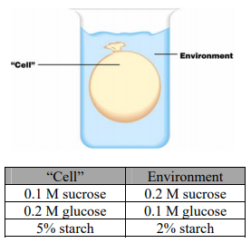
- Assume that the “cell” above is permeable to sucrose, glucose, and water but impermeable to starch. Which of the following statements is correct?
A Starch will diffuse into the cell.
B Starch will diffuse out of the cell.
C There will be no net movement of glucose
D Glucose will diffuse into the cell (E) Sucrose will diffuse into the cell

- Assume the “cell” is permeable to water only. If the cell contains a 0.3 M solution of glucose and the environment contains a 0.1 M solution of glucose, which of the following statements would be true?
A The cell will decrease in volume.
B Glucose will enter the “cell.”
C Active transport will occur.
D There would be a net movement of water into the “cell.”
E There would be no net movement of water.

The following 3 questions refer to the diagram of a cell membrane below. Write the correct letter next to question.
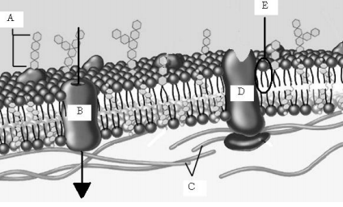
- Contains both polar and nonpolar regions. _____

- Allows larger molecules to pass through the cell membrane. _____

- Molecule that allows ligands (cell signals) to bind, subsequently opening ion gates. _____ - EXTRA CREDIT

- Primarily responsible for cell-to-cell recognition _____

- In the following diagram, one could predict that if passive transport was occurring,
A there would be a net movement of molecules from side A to side
B there would be a net movement of molecules from side B to side
C there would be no net movement of molecules
D there is not enough information to tell

- In the following diagram, side A is ____________ compared to side B.
Side B
Side A
A hypertonic
B hypotonic
C isotonic
D at equilibrium

Written Response
- Not all cells are the same; each cell type differs in their structure to effectively support the cell’s function. Identify a specific cell type that exemplifies this relationship between structure and function (e.g., nerve cell, muscle cell, epithelial cell, sperm cell, macrophage, leaf cell). For the cell that you have selected, discuss the following:
- The type and function of this cell (_____/3 points)
- How does the presence and proportion of specific organelles present in this cell type support the function of this specific cell type. (_____/4 points)
- How does the shape of this cell type support the function of this specific cell type. (_____/3 points)

- Cells respond to their external environment to maintain homeostasis. Consider the following examples and predict how the cell will respond in each of the environments. Support your prediction with an explanation that includes appropriate scientific terminology.

- Scenario 1 – A marathon runner consumes 2 cups (8 oz.) of water every mile for 26.2 miles for a total of 52 cups of water in 3 hours. A typical runner consumes approximately 20 cups of runner in the same activity. What will happen to the runner’s cells? Why? (_____/3 points)

- Scenario 2 – A plant owner goes away on a 2week vacation, but forgets to make plans to have their house plants watered for this time. These houseplants are usually watered every 4 days. What will happen to the runner’s cells? Why? (_____/3 points)

- Scenario 3 – A farmer is interested in increasing their crop yield. Therefore, they apply 4x the amount of fertilizer to the soil than what is recommended. What will happen to the runner’s cells? Why? (_____/3 points)

Extension
Write an organelle riddle of your own, using the characteristic of the organelle to provide clues as to which organelle you are referring. You may do up to 3 riddles.

