Name:__________________________________________

Climate Detectives – Analyzing evidence to solve a climate mystery

Introduction: Climate scientists have determined that Earth goes into a glacial period (or Ice Age) every ~100,000 years or so. The most recent of these glacial maximums was 21,000 years ago, when most of Earth’s surface was very different from its current appearance. Ice sheets 2 or more km high covered Canada, the northern US, northern Europe, and parts of Eurasia. Global sea level was 110-125 m lower, joining modern islands between Asia and Australia and connecting Britain to mainland Europe. South of the ice sheets, conditions were cold and windy, with dust blowing in many areas. The modern forests of North America, Europe, and Asia were regions of tundra or grasslands, and lower levels of atmospheric carbon dioxide and methane caused cooling and drying across the tropics and the southern hemisphere. In broad terms, climate trends have been for Earth to warm since the last glacial maximum to the present time (note: this is different from anthropogenic climate change! We’ll cover this later). This activity will focus on a period of time between 13,000 and 11,700 years ago (a time now known as the Younger Dryas), when data suggests something odd happened.

- What is some of the evidence you think scientists might use to determine how Earth was different during the last glacial maximum? [Discuss this together in your groups, then offer your suggestions to the class, then write down some of the best ideas below. Wild guesses are encouraged!]

Mystery 1 – What happened during the Younger Dryas?
The first mystery is of a kind that scientists have to address all the time, when data showed something unexpected. Dryas octopetella is an arctic wildflower typical of cold, open, Arctic environments. About 75 years ago, scientists in Europe who study the abundance of pollen in sediments over time noticed a surge in pollen counts for the Dryas genus during a certain time period.

- What did climate scientists notice in their data? What story can you tell with these graphs (next page)?

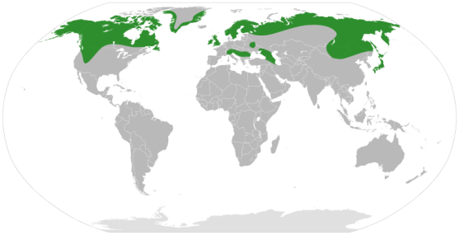
- Describe the distribution of the Dryas wildflower.

Figure 1. Modern distribution of Dryas in green

- Discuss the information being shown in Figure 2.

Figure 2.

- Explain the relationship each of the graphs in Figure 2 have with each other.

Figure 3. “Meltwater pulse.”

- What is meltwater? Is it salt or fresh water?

Mystery 2 – What caused the Younger Dryas?
In order to address this second mystery, you’ll need a better understanding about Thermohaline Circulation, also known as the ocean conveyor belt.

- Discuss what you already understand about Thermohaline Circulation. In your discussion, consider the following:

- What is density?

- What are some unique properties of water?

- What is a solute/solution?

- How do convection currents work?

- The fish-tank demonstration shows some of the above parameters interacting. Record your observations below. Draw a sketch to support your observations.

- Devise a hypothesis linking Thermohaline Circulation to the Younger Dryas. Explain how one would test this hypothesis.

- Describe how you would revise your hypothesis after learning about ancient Lake Agassiz.

- Could something similar happen again? What does Dr. Ward (from the video) think?

- Using your understanding of Thermohaline Circulation and past climate events, discuss how and why rising global temperatures would affect the ocean conveyer belt and in turn impact global climates.

