The Effect of Interspecific Competition
on Population Growth

Data Analysis
- Data entry (as a group)– enter your group’s data in Excel or equivalent
  - Enter the number of Paramecium for each species observed in each slide in each treatment.
- Data analysis (as a group)
  - Calculate the number of Paramecium for each species observed in each slide per 1 mL.
    - There are 20 drops of solution in 1 mL
    - If 5 slides in a treatment were observed, multiplying the number of Paramecium by 4 will show how many organisms would be present in a 1 mL sample.
    - Excel can make this calculation by entering the following:
=number from individual slide counts x 4
  - Calculate the average number of Paramecium for each species per treatment per 1 mL.
    - Excel can make this calculation by entering the following:
=AVE(all of the counts of Paramecium observed in 1 mL)
  - Enter average number of Paramecium for each species per treatment per 1 mL on the class data spreadsheet.
- Calculate the measures of central tendency (e.g., mean, median, mode) and the range for the class data
- Calculate the standard error for the class data
- Identify the statistical measures that you think are most meaningful in answering the research question, “what is the effect of interspecific competition on population growth?” Explain your thinking.

- Graphing results (individual)
  - Generate a graph that depicts the effect of competition on the population growth of Paramecium sp. through time.
  - Include appropriate axes labels, title, and legend.
  - Print the graph in black/white on one page and attach graphs to this paper.

Discussion

- Review the data and graph for the class data. Describe the most notable parts of the data and the trends in data. Refer to the data in your description.

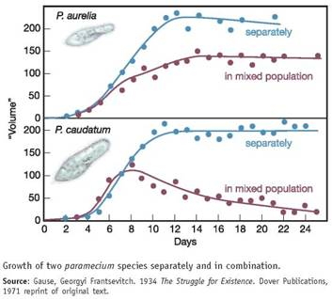
- Georgy Gause, a Russian biologist, examined the effect of competition on the population growth of P. aurelia and P. caudatum. A graph of his results is shown to the side. Compare the class data to Gause’s data. Refer to the data to support your comparison.

- CER – Write a CLAIM that addresses the research question, “what is the effect of interspecific competition on population growth?” Include multiple pieces of specific data-based EVIDENCE to support your claim. Explain what this evidence means and why it supports the claim in a RATIONALE.

CLAIM –

EVIDENCE –

RATIONALE –

- Gause’s experimental findings resulted in an ecological concept known as “competitive exclusion.” Based on your results and Gause’s, explain what “competitive exclusion” means.

- Identify possible limiting factors that may have affected the Paramecium in this experiment. Explain how limiting factors affect population growth.

- Examine the population growth of the Paramecium.
  - Identify the time period when the Paramecium are experiencing exponential growth. Label this on the graphs.
  - Identify the time period when the Paramecium reach carrying capacity. Label this on the graphs.
  - Explain why the populations grow exponentially and why they reach carrying capacity.

- Based on the results generated in this experiment and Gause’s, predict what would happen in the following situations:
  - Paramecium sp. were in an environment without limited resources.

  - Paramecium sp. were in an environment with additional limited resources.

  - An invasive Protist was introduced into the Paramecium’s environment that consumes similar food sources and occupies a similar habitat.

- An organism’s niche describes the role an organism plays in its environment and the resources it uses. The breadth of an organism’s niche is affected by competition. Describe how the scope of the Parameciums’ niches are affected when competition is occurring between the two species.

- Discuss a future research question that could be investigated that would expand upon the ideas explored in this experiment.

