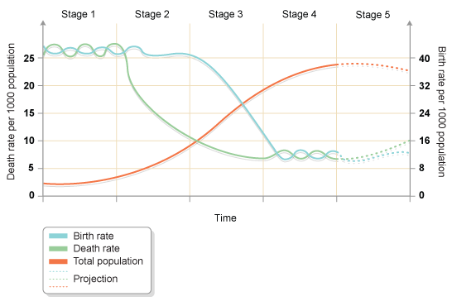
Features | Stage 1 | Stage 2 | Stage 3 | Stage 4 | Stage 5
Birth rate

Death rate

Rate of increase

Reasons for birth rate
Reasons for death rate
Examples of countries

