Topic (__/2 points) ______________________________________________ Name ____________________

Notes
Connections/Questions  (__/5 points) | Terms/Description/Tables/Graphs  (__/10 points)
- Chromosome –

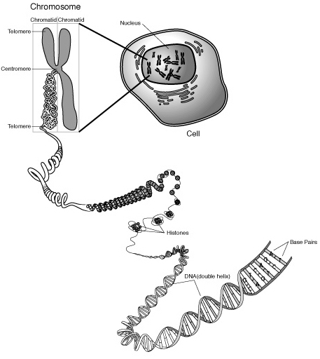

- What is the relationship between a cell, the nucleus, a chromosome, and DNA?

- Humans have ______ chromosomes or ______ pairs, 50% come from ____ and 50% come from ____.

- DNA
  - Structure
    - Determined by

    - Shape –

    - Macromolecule –

    - Subunit –

      - Consists of

- Complimentary base pairing:

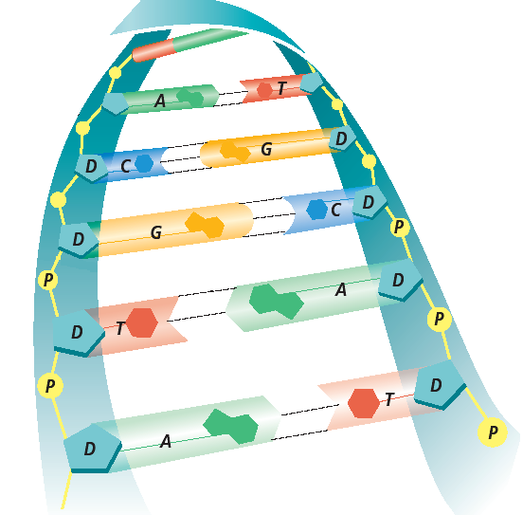

- Cell Division
  - The cell cycle consists of

  - What is the difference between mitosis and cell division?

  - Mitosis
Phase | Description | # of Chromosomes
    - Purpose of mitosis

- Asexual Reproduction
  - Description

  - Types

  - Describe the process of cloning

- What is the relationship between mitosis and cancer?

- Meiosis

  - Why can’t mitosis be used for sexual reproduction?

  - Process:
Phase | Description | # of Chromosomes | # of Cells

    - Purpose of meiosis

    - How does genetic variation arise in meiosis?

    - Comparison of mitosis and meiosis
 | Mitosis | Meiosis
Purpose
Chromosome number
# of Cells
Genetic variation

- Fertilization
  - Purpose

  - Process

Synthesis
Summary & Reflection
(__/5 points)

