Evidence of Evolution

- Review the evidence of evolution found at each of the six stations.
- For each piece of evidence, explain how it supports the idea that organisms of different species share a common ancestor.
- For each piece of evidence, explain how the evidence supports evolution by natural selection.

Station 1 – Homologous Structures
A.
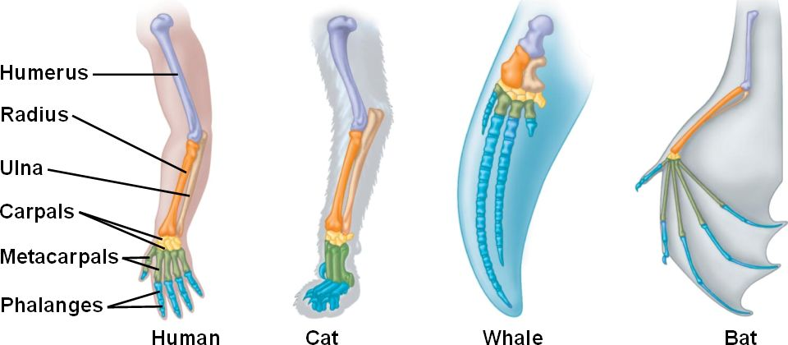

B.
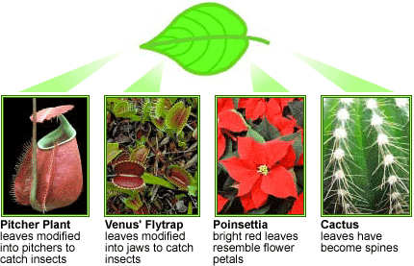
Each leaf has a very different shape and function, yet all are homologous structures, derived from a common ancestral form. The pitcher plant and Venus' flytrap use leaves to trap and digest insects. The bright red leaves of the poinsettia look like flower petals. The cactus leaves are modified into small spines, which reduce water loss and can protect the cactus from plant-eaters.

C.
Months before you were born, one of your genes, called Pax-6, turned on and helped your developing body build eyes. However, we are not the only species equipped with a copy of this gene. Other mammals, birds, fish, and even insects also carry a version of Pax-6. In fact, Pax-6 seems to do about the same job in all of these species. The human version of the gene can be inserted in a fly and still trigger the building of an insect eye!

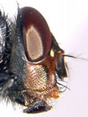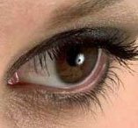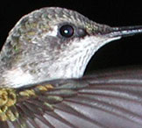

D.
Biologists found that as a baby mammal grows in its mother's womb, two bones in the skull become ear bones. However, as a baby lizard develops in its egg, the same two bones become part of the jaw! This is strong evidence that these mammal ear bones are homologous to jaw bones in lizards! Compare the colors of the bones in the diagrams below to find out which mammalian and lizard bones develop from the same structures.

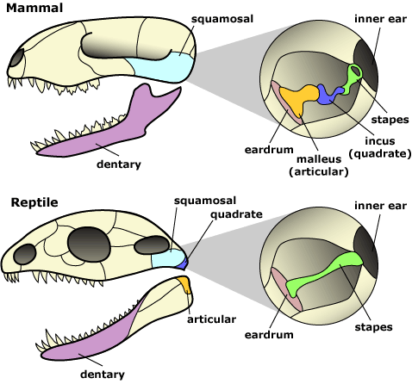

E.
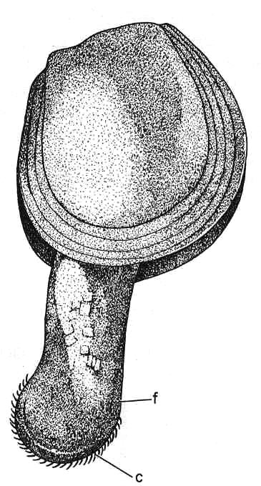
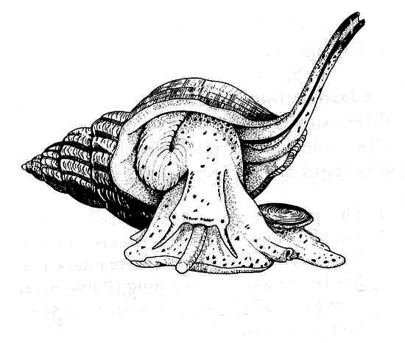
The 'foot' of all the molluscs is also homologous. The pictures below show the shells of the three main types of molluscs with the foot projecting from it. One has tiny eyes and is a crawling appendage (gastropod), another has not eyes and is a digging device (bivalve or pelecypod), and the third has big eyes, numerous tentacles, and a tube for jetting out water and propelling itself as it swims (cephalopod). 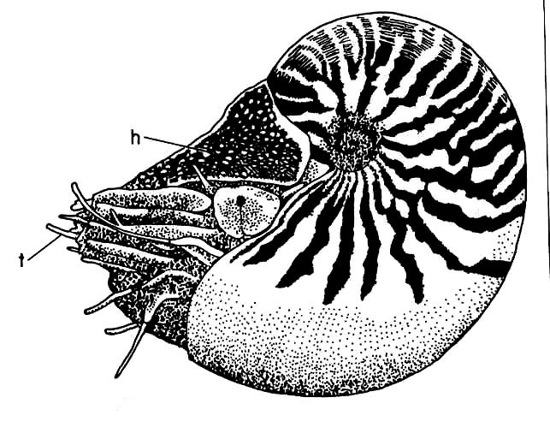

Station 2 - Embryology

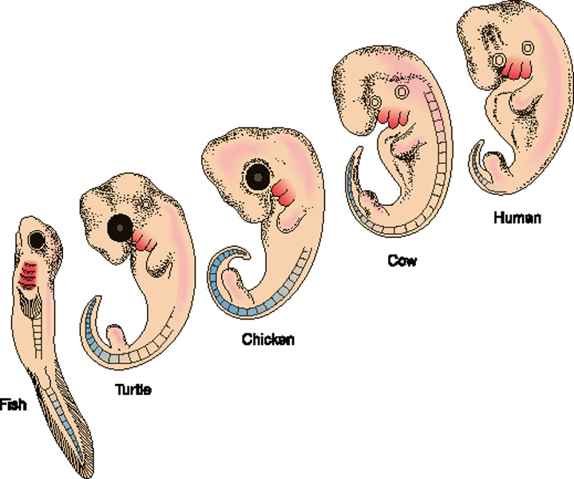

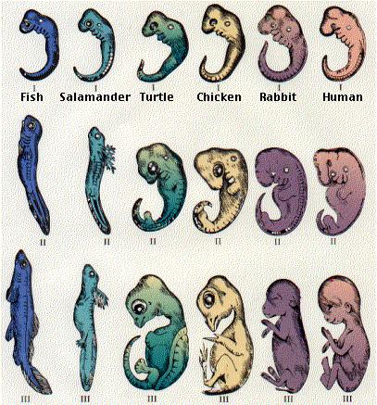

Station 3 – Vestigial Structures

A.
Fish species that live in completely dark caves have vestigial, non-functional eyes. When their sighted ancestors ended up living in caves, there was no longer any natural selection that maintained the function of the fishes’ eyes. So, fish with better sight no longer out-competed fish with worse sight. Today, these fish still have eyes—but they are not functional and are not an adaptation; they are just the by-products of the fishes’ evolutionary history.

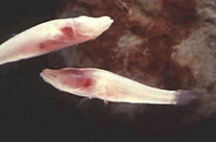

B.
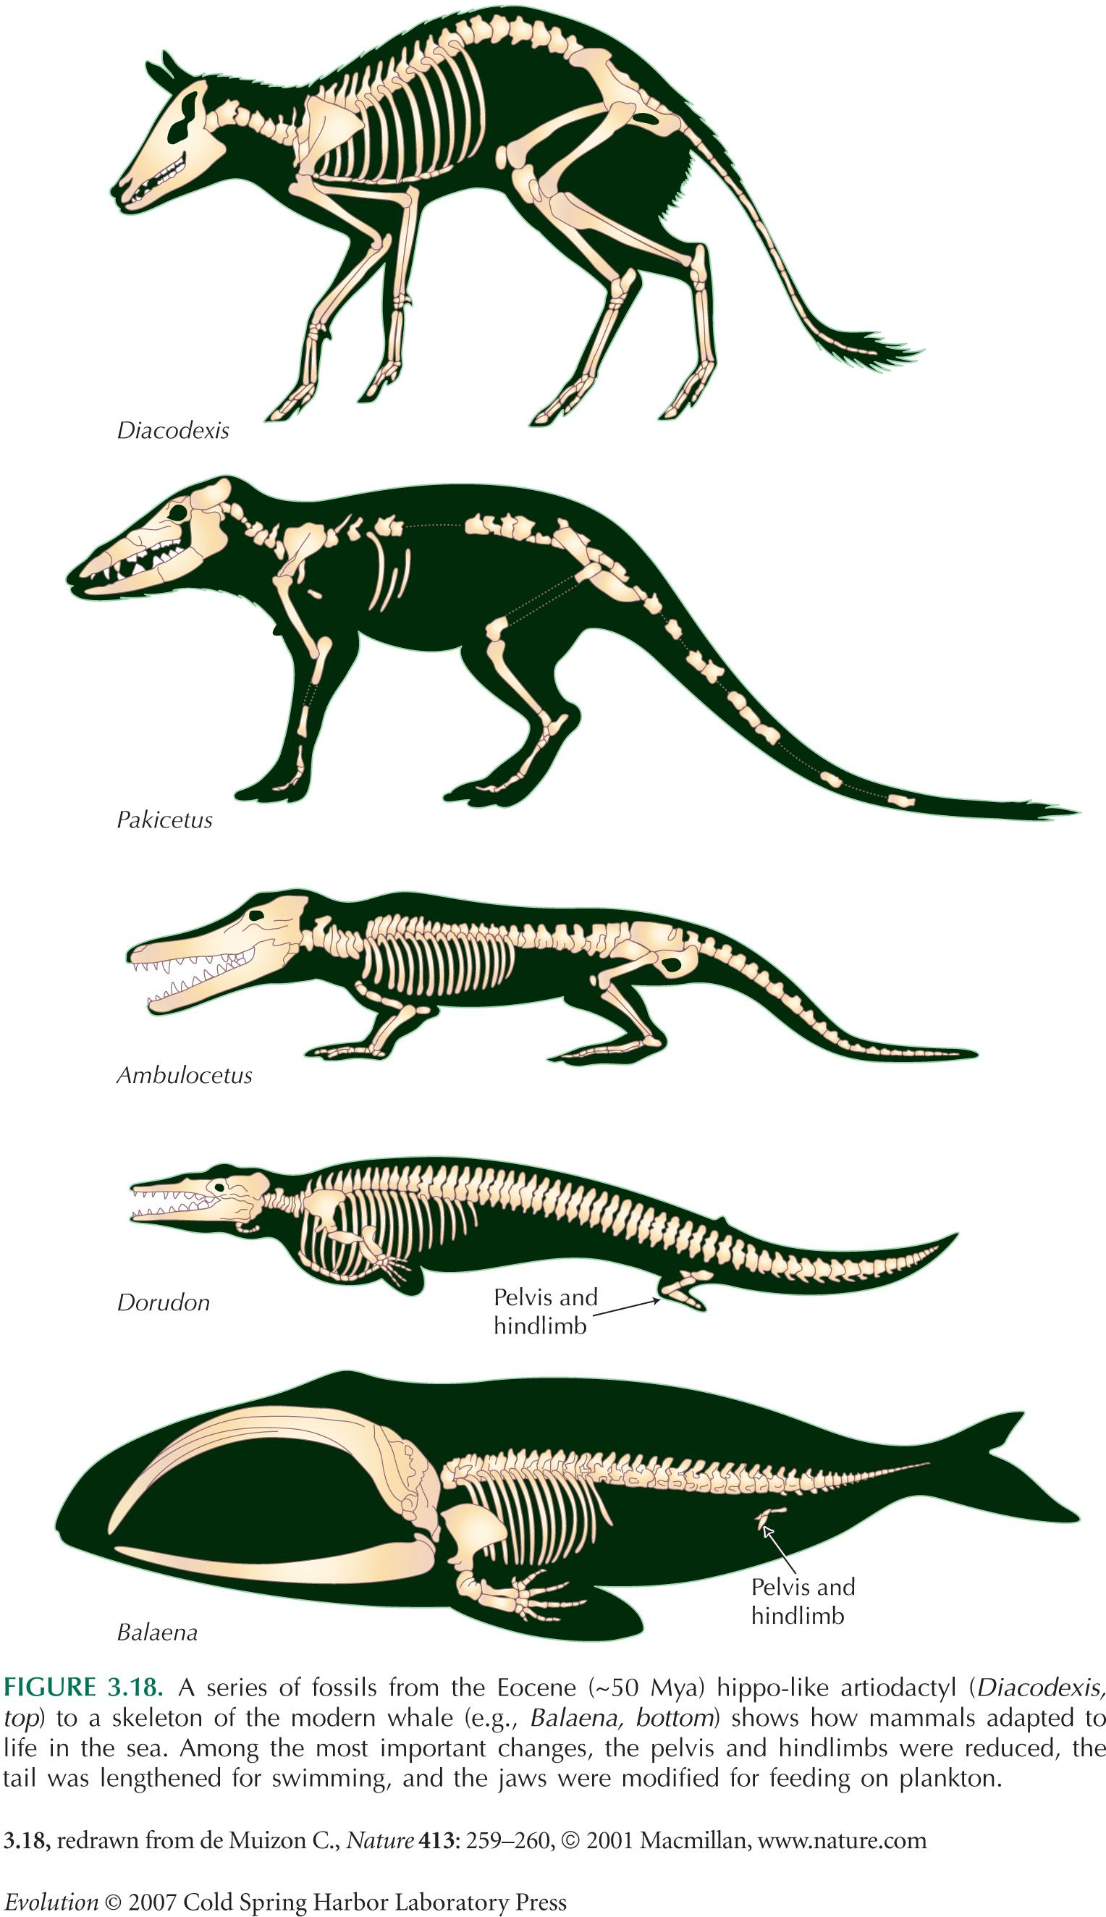

C. Femur bone in snakes
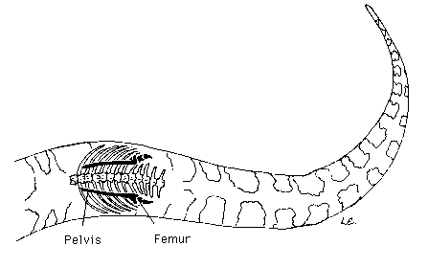

D.
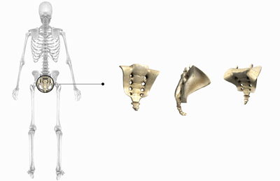

Station 4 – Genetic Similarities

A.
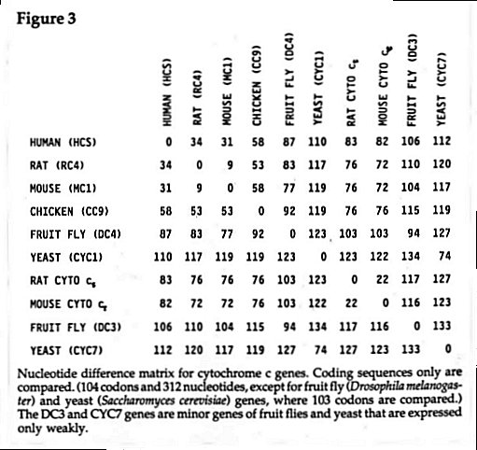

B.
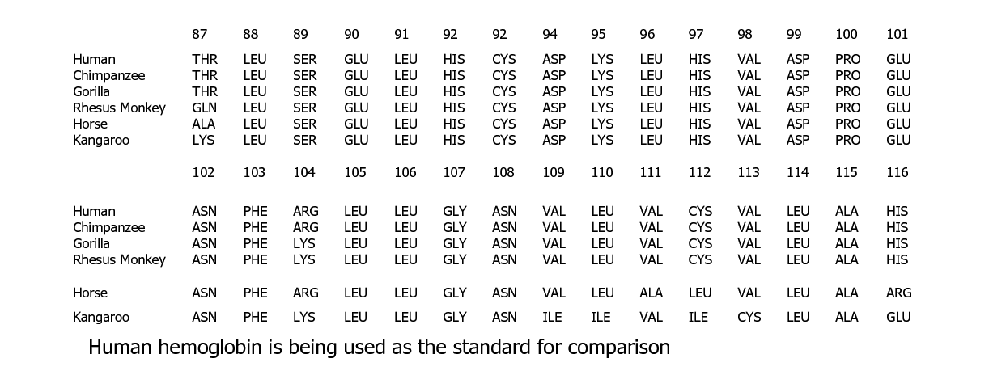

Station 5 – Fossil Evidence
A. Primate skulls
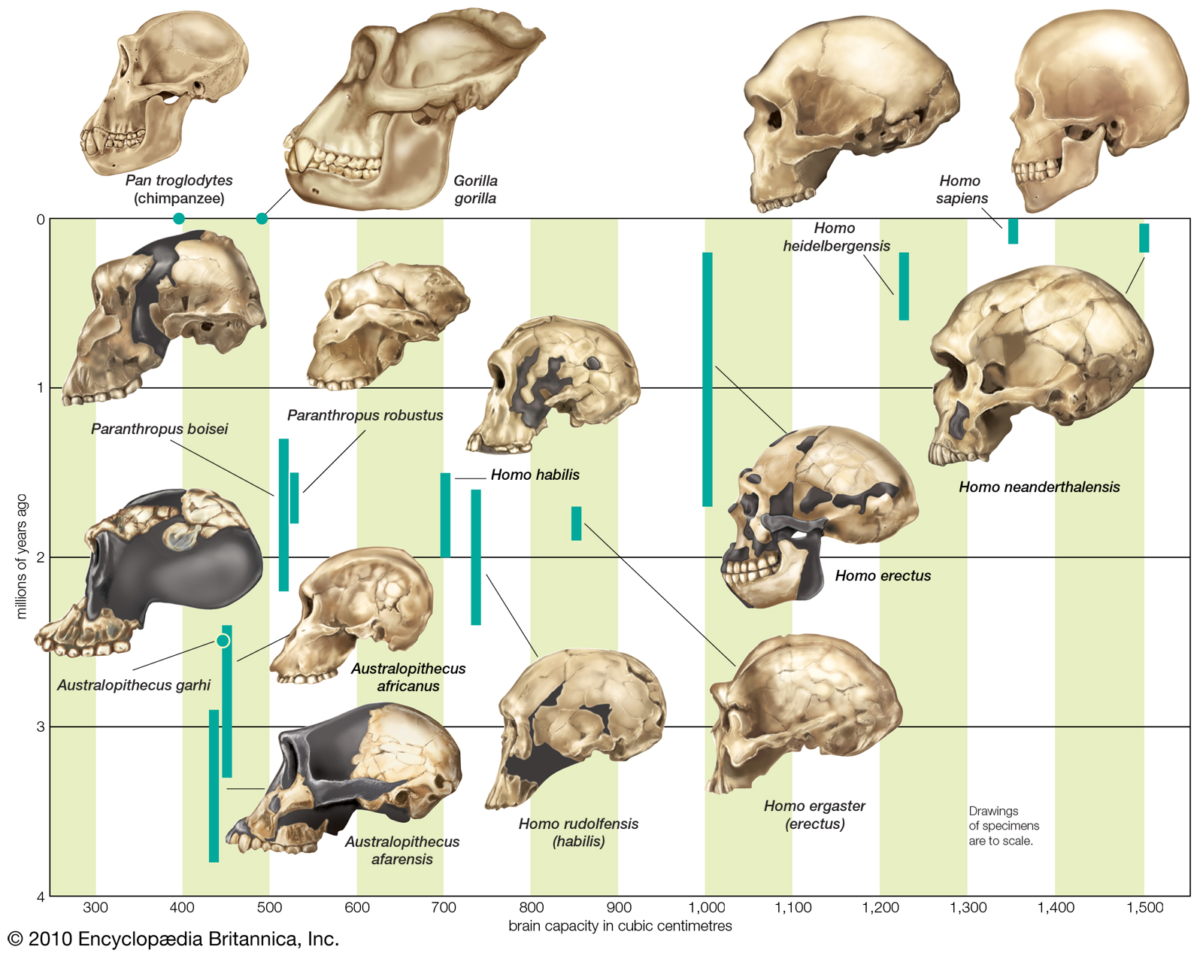

B. The Eocene Horse
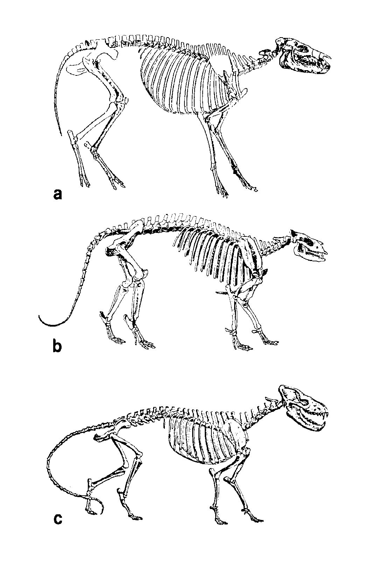

C. Ancestral fossil record of modern whales

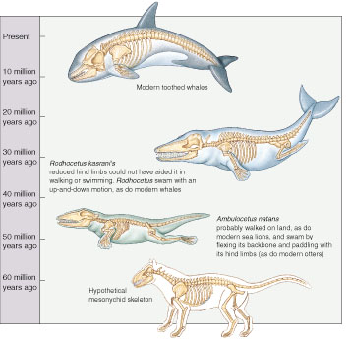

Station 6 – Geographic Distribution

A.
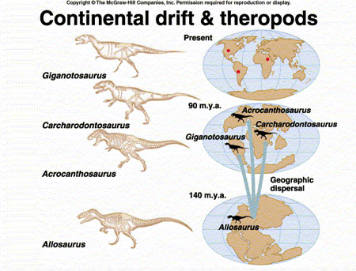

B.

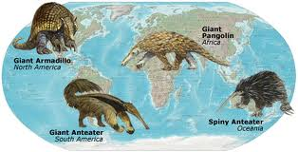

C.

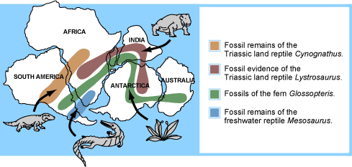

Station 7 – Analogous Structure

