Sign In
WISDOM SHOP MORE

- RECIPE CENTRAL
- MIND & BODY
- NEWS
- NUTRITION
- PARENTING
- NATURAL ANTIBIOTICS
- SUPER FOODS
- SUSTAINABILITY

3 Reasons To Go Against The Flow Hive
By maryam henein |
Posted on Aug 19, 2017
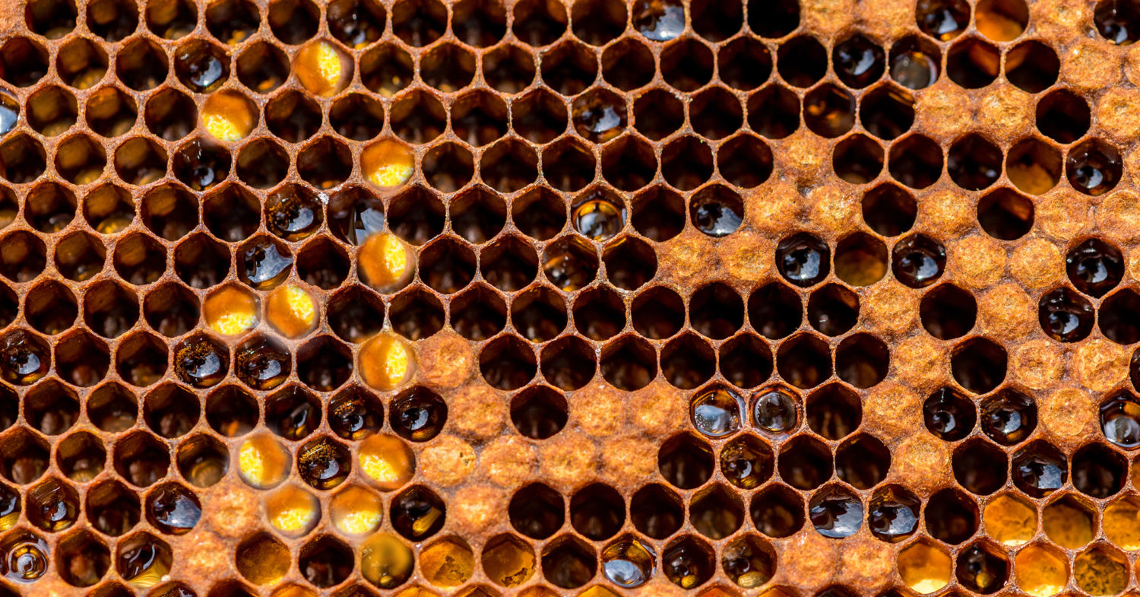

- SHARE
- TWEET
- EMAIL
The Flow Hive is not as sweet as it seems.
On World Honey Bee Day lets take a look at where bees are currently. According to a new U.S. Department of Agriculture study, honey bee populations are on a three percent rise, so far, in 2017. Additionally, Colony Collapse Disorder is down 27 percent compared to numbers in 2016. These numbers sound promising, but compared to the 90 percent decline of colonies over the past twenty years and our current administration, it’s difficult to find comfort. Consider that the EPA refuses to put the rusty patched bumble bee (Bombus affinis) on the endangered species list and refuses to protect bees against pesticide coated seeds. Truth is, bees are still in trouble and although there are innovators attempting to help, they are actually doing more damage to bees than helping solve the problem.
Frankly, I am tired of people raving about how wonderful the Flow Hive invention is and posting it on my Facebook wall every other day. The viral-ity of this fundraising campaign was astounding. During my travels in Central America, I even had a Belgium restaurant owner in Nicaragua ask me whether I’d heard about it.
“I love honey. This is amazing,” you’ve read over and over again in the comments from people worldwide who have no clue what goes into beekeeping. The gadget allows you to harvest honey without opening the hive; and Australian inventors, Stuart and son Ceder Anderson, promise that there is “no mess, no fuss, no expensive processing equipment, and (that) the bees are hardly even disturbed.”
But just because no disturbance can be viewed by the naked eye doesn’t mean the bees aren’t being disturbed. How arrogant humans can be.
The Flow Hive has raised over $13 million and counting. Perhaps folks genuinely want to help the bees and think this gadget is the answer. Meanwhile, this is a testament that urban beekeeping is thriving.
Supporters argue that by simplifying (or automating) the most time-consuming part of beekeeping — the harvest — more people may want to take up beekeeping; more beekeeping may lead to greater support to save bees and therefore Flow Hive is a positive thing.
At first glance, I too thought Flow Hive was a genius invention that honors the bees but after looking under the proverbial lid, I’ve concluded that the device reduces nature’s miracle into a beer keg. It’s animal husbandry with a negative twist.
“One wants to see this be successful, easy to use, and contribute to the world of improved beekeeping,” adds Kim Flottum, beekeeper and editor of Bee Culturemagazine. “But there’s the concern, far in the back of my mind, that it may appear to make things too easy, fostering, not improved beekeeping, but reduced attention to maintaining healthy bees.”

3 Reasons To Avoid The Flow Hive
Here are three of the multiple reasons why many folks refrain from using Flow Hive and consider it to be just another level of separation between bees and beings.

1. Plastic Comb
This newfangled honey collection system is comprised of plastic. It’s basically the Langstroth hive on steroids. The bees build their own wax on top of plastic frames and fill the cells with nectar and cap per usual. When you turn on the tap, preso — honey squeezes through the center of a plastic double-walled comb construction. Once draining is completed, you can reset the tap, and the comb goes back to its original position. Automation is in full effect.
Bees don’t particularly like plastic. Ask any organic beekeeper; they don’t need it. They fashion wax – a living substance – out of their own abdomens. Wax is where they store their food (nectar and pollen) and house their young. Wax vibrates and changes temperature.
“For bees, comb is far more than a Tupperware container for somebody else’s lunch; it is the tissue and frame of the hive and as such it forms multiple functions,” writes Beekeeper Jonathan Powell, who has a a long family connection with bees, and is also a partner with a UK Charity called the Natural Bee-keeping Trust.
In his blog he writes:
Cells have wall thicknesses of just 0.07 mm, and are made from over 300 different chemical components. Wax removes toxins from the honey. The resonant frequency (230-270 Hz) of the comb is matched to the bees’ vibration sensors and acts as an information highway between bees on opposite sides of the comb. Bees manage the temperature of the cell rims to optimize transmissions of these messages. Wax holds history and memory via chemical signals put into it by the bees.
But instead of working with the wax comb they’ve created, the Flow Hive forces bees to deal with hormone-disrupting plastics that off-gas.
“Honey bees are able to recognize the smallest differences in wax composition but not polypropylene,” adds Powell.
Additionally, the best honey is fully capped. It’s like putting a lid on a jar; honeybees ripen nectar by removing the moisture and sealing it off with wax. Honey that has been harvested with a moisture content above 20 percent and isn’t capped is considered unripe and may ferment. Traditional beekeepers slice honey caps off with a knife and use a spinner which removes honey from wax frames. They then reuse the wax in their hives once more.
Meanwhile, in colder climates honey often crystallizes, which means the Flow Hive may clog and require heating, killing the healing properties.
Incidentally, a Langstroth hive can be managed without any comb (so you let the bees make their own). It’s how the backward beekeepers like Kirk Anderson and Dee Lusby run their hives.

2. Non-Existent Communion Between Bees & Beings
The Flow Hive is touted as a “beekeeper’s dream.” But in my opinion, it’s a wannabe’s fantasy. The point of beekeeping is to commune with the bees, not to further remove oneself from them. There’s nothing like slowing down, with reverence and care, to peek into a hive and observe the virgin sisters of toil. Bees work themselves to death, so why should we have such easy access to their food?
Beekeeping involves putting on a bee suit (or not) and tuning into the bees to ensure that no harm is done when you go into their sacred space. And if you happen to get stung once or twice, you can choose to see it positively. It’s medicinal.
As the Italian photographer and fellow beekeeper Renée Ricciardi writes:
Beekeeping involves respect, patience, and attention to the natural world. After years of beekeeping you become attentive to humidity every time you step outside, you start noticing which flowers bloom first, you stop hating pesky dandelions, and when it rains you think of the bees.
Just like there is an indescribable satisfaction in eating food that you’ve grown, there’s something magical about beekeeping. And it doesn’t involve turning on a tap. Actually many hobby beekeepers will tell you that honey is not the main attraction. Stewardship is. And that entails checking on the health of the colony, observing brood patterns, examining the queen, making sure there aren’t any parasites or pathogens, and observing the honey flow so you know what to leave behind.
With an automatic honey appliance, you get none of that. Even though there’s a window and you can see the bees, you are clueless as to what is actually going on with the hive. As a friend recently stated, “Flow Hive promotes the emotional detachment of factory farming.”
Commercial beekeeping meanwhile is a whole other ball of wax. It is arduous work, involving long hours and a lot of casualties. You may likely have to:
- Get Suited Up
- Smoke the Bees
- Open the hive
- Remove the honey-filled frames
- Brush the bees from those frames
- Use a knife to remove the capping from the wax cells
- Use a centrifuge to get honey out of the frame
Flow Hive promises to remove all that “messy hard work.” Which commercial beekeeper wouldn’t be intrigued? Yet without some sort of communion, doesn’t the process kind of look like honey-robbing? Hands-off beekeeping? Free honey? Come on, it’s fast food honey that cuts corners.
Incidentally, honey has its own flow depending on the season and is usually harvested only once a year. Will wannabe beekeepers be mindful of nature’s rhythms or simply gorge on honey all year round? Most beekeepers, including myself, will tell you that honey is just a bonus. I keep bees because I love having them around. It’s a bee-centric, rather than honey-centric, endeavor. That’s why they called their movie More Than Honey.
Consider this: In the six-week lifespan of one single bee, she will only produce a quarter of a teaspoon of honey. Honey is sacred.
“I always tell beginners in my workshops, there is only one real reason to keep bees, and that is because they are fascinating. If you just want honey, make friends with a beekeeper,” says a beekeeper in Australia who goes by Adrian the Bee Man.

3. Expensive Gimmick
“The Flow Hive is now the largest international campaign ever on Indiegogo,” announced Slava Rubin, CEO of Indiegogo.
They surpassed their goal of 70,000 in less than 10 minutes and raised $2.1 million in one day, setting a record for the most funds raised in 24 hours.
For $600, you get a full automatic bee farm. But many beekeepers I’ve spoken to believe that it’s overpriced and unsustainable. Flow Hive actually costs more than a standard Langstroth hive.
Flow Hive has been described as a possible “key in keeping the world’s bee population from further decline.” Really? How so? This just makes honey collection simpler and easier. How does it help bees survive the issues they are currently grappling with? Like systemic pesticides and loss of habitat???
To quote Ricciardi once more, Flow Hive invites “lazy, hungry honey-eaters who are also terrified of being stung. It will create a generation of oblivious people who don’t know the delicate mechanics of the beautiful hive.”
Don’t get wooed by the hype and the mesmerizing images of honey. Get involved with Center For Food Safety or show Vanishing of the Bees to your children. Or take up real beekeeping. Participate in direct bee activism.
Please note that no one is saying that these people are bad. But as they say, the road to hell was paved with good intentions. and “good inventions” too.
Not everything that has to do with bees is good for the bees.

