**Integumentary System: Lab Exercises**

**Introduction**: The Integumentary system includes the skin, hair, nails, sebaceous glands, and sweat glands. These organs provide a protective covering for deeper tissues, aid in regulating body temperature, prevent water loss, get rid of wastes, and aid in communication using sensory receptors.

**INVESTIGATION #1, Human Skin**

**Objective**: To become familiar with the different characteristics and structures of the integumentary system.

**Materials**:

* Dissection microscope
* Ruler

**Proecedure**:

1. **Palm of hand and Back of hand**
   1. Look at your hand, back and front. Pull on the skin of the back of your hand and the palm.
   2. Using a dissection microscope or magnifying glass, examine the skin surface of your palm.
   3. Using a dissection microscope or magnifying glass, examine the skin surface of the back of your hand.
   4. In your observations look for any regular patterns that you see. You will need to describe all that you see.
   5. Examine any cuts or scars that may be present on your skin. In your observations describe the appearance of these features.
   6. On the back of your hand, you will find fine hairs. Examine the point at which the hair protrudes from the skin. Describe the area immediately around the hair and the angle at which the hair leaves the skin.
2. **Fingernails -** Examine the fingernails. Draw what you see in the observations sections.

1. **Hair and hair root -** Use a compound microscope to look at a hair. Examine the roots, the hair shaft and split ends. Draw what you see in your observations.

**Observations:**

1. **Palm and backhand under a microscope**
   1. Is the skin on the back of your hand firmly attached to the underlying tissues, or can it be lifted away? **(1 point)**
   2. How does this compare with the skin on the palm of your hand? **(1 point)**
   3. Why do you think the skin at this point on the body acts this way? (**1** **point**)
   4. Draw a diagram of a small area (3cm x 3cm) on the back of your hand. **(1 point)**
   5. Draw a diagram of a small area (3cm x 3cm) on the palm of your hand. **(1 point)**
   6. What is different in the patterns on the palm and on the back of the hand? **(1 point)**
   7. Describe the area immediately around the hairs of your hand. What angle does the hair leave the skin in most cases? **(1 point)**
2. **Fingernail**
   1. Draw a diagram of your fingernail under the microscope. **(1 point)**
   2. Describe the appearance of your fingernail under the microscope. **(1 points)**
3. **Hair and hair root**

a. Draw a diagram of your hair and hair root under the microscope. **(1 point)**

**Discussion:**

1. On your hand, where does the skin appear to be the thickest? Where is it the thinnest? Why does the skin vary in thickness? **(1 point)**
2. In your experience, do small cuts in the surface of the thick pads on the palms of the hands draw blood or cause pain? Explain your answer. **(2 point)**
3. Distinguish among the epidermis, dermis, and subcutaneous layers. What characterizes make them unique. **(1 point)**
4. In which layer of the skin are the sebaceous glands found? **(1 point)**
5. How are sebaceous glands associated with hair follicles? **(1 point)**
6. In which layer of skin are sweat glands located? **(1 point)**
7. Why is there so much adipose (fat) tissue under the dermis? **(1 point)**
8. Why would YOUR skin snap back faster than a parent’s? **(1 point)**

**ACTIVITY #2, Fingerprints**

MCj02979430000[1]

**Objective:** To explore the uniqueness of human fingerprints

**Materials:**

Ink pad

Pencils

Fingerprint collection chart

**Procedure:**

1. **Fingerprint practice**
   1. On a scrap piece of loose leaf make a few trials of your finger prints.
      1. Do one finger at a time.
      2. Roll the finger on the paper using light pressure.
      3. Make sure you do not add too much ink as all you will get is a blob of ink.
2. **Fingerprint recording**
3. When you have mastered the technique make a print of each of your fingers on one hand.
4. Refer to the diagram to see your type of prints.
5. Record the type of print in the space below your prints.
6. Repeat procedures 1-3 using the other hand
7. **Using fingerprints**
   1. See Ms. Moretz to make a fingerprint sample.
   2. Wash your hands. **DO NOT MAKE A MESS IN THE BATHROOM/SINK.**

**Observations:**

**Finger Print Chart**

|  |  |  |  |  |  |
| --- | --- | --- | --- | --- | --- |
| **Hand** | **Thumb** | **Index** | **Middle** | **Ring** | **Pinky** |
| **Right** |  |  |  |  |  |
|  |  |  |  |  |  |
| **Left** |  |  |  |  |  |
|  |  |  |  |  |  |

**Discussion:**

1. What were some of the difficulties you experienced while trying to make your fingerprints? **(1 point)**
2. What were some of the things you noticed while trying to classify the type of fingerprints you have? **(1 point)**
3. Before computers and national fingerprint registries, people had to rely on their eyes to catch criminals. Explain how this would take a long time, based on your own search in the classroom? **(1 point)**
4. What are the chances of someone else having prints like yours (ratio)? **(1 point)**

**INVESTIGATION #3, Visualizing Changes in Skin Color due to Continuous External Pressure**

**Objective:** To explore the skin’s response to changes in pressure.

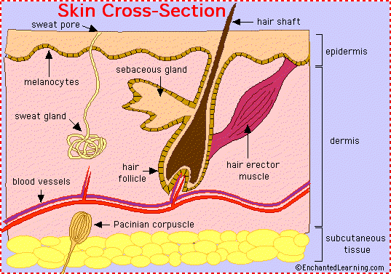

**Procedure:**

1. Obtain a small glass plate.
2. Press the heal of your hand firmly against the plate

for a few seconds and then observe and record the

color of your skin in the compressed area by looking

through the glass.

**Observations/Discussion:**

1. What is the color of the compressed skin? ______________________
2. Why does the color of the skin change? _______________________________________________
3. What would happen if the pressure was continued for an extended period in this area?

______________________________________________________________________________

**INVESTIGATION #4, Testing Tactile Localization**

**Introduction:** Your skin has many sensory “touch” receptors. Tactile localization is the ability to determine which portion of the skin has been touched. Once the skin’s sensory receptors have received a message it sends this message to the brain and then the brain interprets the location and “meaning” of the feeling. (rough, smooth, soft, tickly, painful, etc.…) The more sensory receptors in an area of the skin, the more accurately the brain can interpret the location.

**Objective:** To determine the location of the skin’s tactile receptors.

**Procedure**:

1. Make sure your subject’s eyes are closed. The experimenter touches the palm of the subject’s hand with a marker. The subject should then try to touch the exact point with his/her own marker (different color).
2. Using a ruler, measure the error of localization in millimeters (the distance between the 2 marks).
3. Repeat the test in the same spot two more times, recording the error of localization for each test.
4. Average the results of the three trials and record your data in the chart.
5. Repeat this procedure on the fingertip, ventral forearm, and the back of hand.

**Data Collection:**

**Testing Tactile Location**

Body Area Tested Average error of localization

Palm of hand _______________

Fingertip _______________

Ventral forearm _______________

Back of hand _______________

**Discussion:**

1. Does the ability to localize the stimulus improve the second time? The third time? Why do you think this happened?
2. Which area has the smallest error of localization and is therefore the most sensitive to touch?
3. Why do you suppose there is a difference in sensitivity in different body parts?

**INVESTIGATION #5, Demonstrating Adaptation of Touch Receptors**

**Introduction:** In many cases, when a stimulus is applied for a long period of time, the rate at which the receptors respond slows down. Your awareness of the stimulus declines or is lost until a change in the stimulus occurs. This is referred to as ADAPTATION. The touch receptors adapt.

**Procedure:**

1. Make sure your subject’s eyes are closed.
2. Place a coin on the anterior surface of the subject’s forearm, and determine how

long the sensation persists for the subject. Using a timer, record the duration of

the sensation in seconds in the chart.

1. Repeat the test, placing the coin at a different forearm location. Record the

duration of the sensation.

1. After awareness of the sensation has been lost at the second site, stack three

more coins atop the first one. Ask, does the pressure sensation return? If so,

record the duration of the sensation.

**Discussion:**

1. Are the same receptors being stimulated when the four coins, rather than one coin, are used? Explain your reasoning.

**INVESTIGATION #6, Plotting the Distribution of Sweat Glands**

**Introduction:** The appendages of the skin (hair, nails, sweat glands and oil glands) are all seen on the epidermis, but they begin in the dermis. Pores are the outlets for sweat glands and are widely distributed in the skin. The sweat glands are controlled by the nervous system and are an important part of regulating the temperature of the body. The sweat glands secrete perspiration when the body temperature gets too high. When the perspiration evaporates off the skin it carries large amounts of body heat with it.

**Procedure:**

1. Using the iodine solution, paint an area of the left palm of your hand (avoid the creases) and a region of your left forearm. The painted area should be slightly larger than the paper squares to be used.
2. Allow the iodine to dry.
3. Mark one paper square with an “H” (for hand) and the other with an “A” (for arm). Tape each paper square over each iodine-painted area, and leave them in place for 15 minutes.
4. While waiting, continue to the next lab.
5. After 15 minutes, remove the paper and count the number of blue-black dots on each square. The appearance of a blue-black dot indicates the appearance of an active sweat gland. (The iodine in the pore dissolves in the sweat and reacts with the starch in the paper to produce the color.)

**Results:**

**1.** Which skin area tested has more sweat glands?

2. Why do think this is?

**INVESTIGATION #7, Microscopic Examination of Hair**

**Introduction**: Hair is a form of protection and helps to maintain body temperature. The hair follicle is structured from both the epidermal and dermal cells. If you look carefully at the structure of the hair follicle you will see that it generally is in a slanted position. Small bands of smooth muscle cells – arrector pili – connect each hair follicle to the dermis. When these muscles contract the hair follicle is pulled upright, dimpling the skin surface causing the appearance of *goosebumps*.

**Procedure**:

1. Rub your fingers across your eyebrow and see it you can pluck an eyebrow hair to view under the microscope.
2. Once you’ve obtained your piece of hair, make a dry mount slide and view it under the microscope.
3. Examine it under low power, then medium, and then high power. Look for the small scale like structures of the hair shaft and the bulb. Illustrate your observation when viewing under medium or high power. Be sure to document the total magnification of the image your drew.
4. Repeat steps 2 & 3 using an eyelash and a piece of hair from your head.

**Results**:

How were the hairs similar?

How were the hairs different?

Eyebrow ______x

______

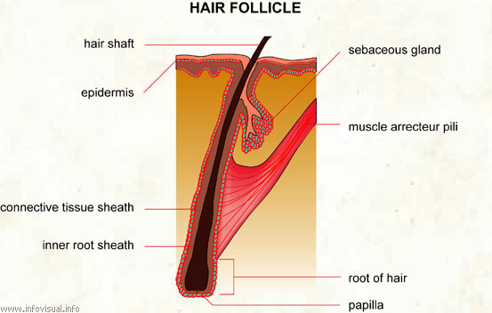

Eye lash ______x

______

Head Hair ______x

______

**REFLECTION**

Write a paragraph that discusses the following:

* The biological reasons for having different thicknesses at different parts of your hand.
* The biological reasons for unique fingerprints.
* The biological reasons for feeling one prick point to the skin or two.
* The biological reasons for differences in skin sensitivity.