The Effect of Ecosystem Disturbance on the Population Density of Euphorbia myrsinites

Field Trip Agenda

- Leave SLCSE for Dry Creek at 8:45
- Arrive at Dry Creek at 9:05, parking at the JCC
- Walk to sampling site 9:05 – 9:15
- Review of sampling technique and probability 9:15 – 9:25
- Sampling of Dry Creek trail 9:25 – 10:45
- In-the-field data analysis 10:45 – 11:05
- Walk back to bus 11:05 – 11:15
- Depart Dry Creek at 11:15
- Return to SLCSE by 11:35

Introduction
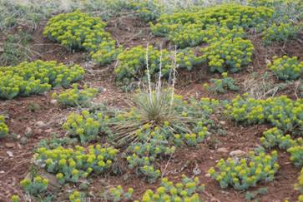
Ecosystems are a network of interdependent relationships between the biotic and abiotic components of that system. Scientists often need to consider the distribution and density of populations found within an ecosystem to better understand the success of the specific species as well as the health and productivity of its ecosystem. For example, an ecologist may assess the population distribution of an endangered species to determine the population’s likelihood of survival, the environmental factors influencing its survival, and the overall health of the ecosystem.
Ecologists may also investigate the size and distribution of a population of invasive species. An invasive species is any non-native species that is causing or could potentially cause harm to the environment, economy, or human health. Scientists try to understand the factors affecting an invasive species’ success so as to effectively control the populations’ spread and decrease its negative impacts.
Myrtle Spurge, Euphorbia myrsinites, also known as creeping spurge, "donkey tail" or broad-leaved glaucous spurge is a succulent plant native to southeastern Europe and Asia Minor. It has been artificially introduced as a decorative garden plant in other areas, especially North America. Although previously cultivated for landscaping dry areas, myrtle spurge is now recognized as noxious, and is invasive in Colorado, Utah, and California. Myrtle spurge deters the growth of native plants by making the soil toxic for other species to grown in. Its rapid growth and reproductive rate along with its ability to thrive in dry conditions make it a superior competitor to native species. It can be controlled through manual and chemical control. It has been found in abundance along the trail of Dry Creek in Salt Lake City, UT.
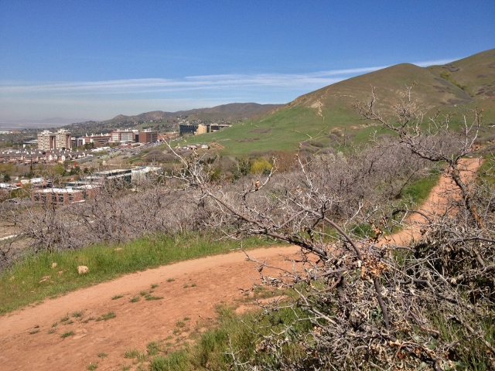
Ecosystem disturbance is one factor that is thought to affect the success of invasive species. Disturbance is a physical, chemical, or biologically caused change in an ecosystem. A tornado, for instance is a non-anthropogenic caused disturbance whereas clear-cutting is a human-caused one. Trails may also be considered a disturbance, because it alters the natural landscape and potentially results in greater light levels, higher temperatures, and lower soil moisture levels.
In this field study, you will investigate the effect of ecosystem disturbance on the density of Myrtle Spurge along Dry Creek. Dry Creek is a trail located near the University of Utah and is popular mountain biking trail. At the field site, you will employ a quadrat sampling technique to quantify how the amount of myrtle spurge changes as you increase the distance from the Dry Creek trail.

Objective
To determine the effect of ecosystem disturbance on the density of Myrtle Spurge along the Dry Creek Trail.

Experimental Design

- Independent variable – distance from trail
- Dependent variable – amount of Myrtle Spurge
- Control - none
- Trials - 3
- Constants – size of quadrat, distance between transects, distance between quadrat spacing, placement of quadrat, time of sampling, location of sampling

Procedure
- Record meta-data of each site on dates of sampling.
- Beginning at the start of the forested area along the Dry Creek trail, extend a measuring tape along the Dry Creek trail for 100 meters.
- Place transects (sampling lines) 5 meters apart along the 100 meter measuring tape. Begin the transect at the edge of the Dry Creek trail and extend for ________ meters. If necessary, stop sampling along the transect if the slope becomes too steep for safe sampling.
- Use the 1 m² quadrat method to sample vegetation along the line transect.
  - Start sampling at the edge of the trail (0 m).
  - Place the 1 m² quadrat to the left side of the transect.
  - Observe all vegetation located within the quadrat. Record the different number of plant species found within the quadrat.
  - Determine the percent cover of Myrtle Spurge within the quadrat. Since a 1 m² quadrat is being used, 10 x 10cm is 1% cover. This is roughly the size of an extended hand with the last two joints curled under. Thus, you can use your hand as a 1% visual gauge.
  - Continue sampling at every subsequent ____m point along the tape.

Meta Data

Temperature ___________________________________________
Wind___________________________________________
Cloud Cover___________________________________________
Other( )___________________________________________
Elevation___________________________________________
Light Levels___________________________________________
Vegetation __________________________________________
Other( )___________________________________________

Hypothesis ___________________________________________________________________________________________________________________
________________________________________________________________________________________________________________________________

Data Collection
- Record the different number of plant species and percent cover of Myrtle Spurge at different distances from the trail in the tables below.
- In the classroom, we will combine individual group data for further analysis.

Trial Number _________________ Transect Number _______________________

Distance from Trail (meters) | Number of Plant Species | Cover of Myrtle Spurge (%)

Trial Number _________________ Transect Number _______________________

Distance from Trail (meters) | Number of Plant Species | Cover of Myrtle Spurge (%)
Trial Number _________________ Transect Number _______________________

Distance from Trail (meters) | Number of Plant Species | Cover of Myrtle Spurge (%)

Trial Number _________________ Transect Number _______________________

Distance from Trail (meters) | Number of Plant Species | Cover of Myrtle Spurge (%)

Trial Number _________________ Transect Number _______________________

Distance from Trail (meters) | Number of Plant Species | Cover of Myrtle Spurge (%)

Data Analysis and Conclusion (in the field): Respond to the following questions in your journal.
- Draw a rough graph of your findings.
- Based upon your observations in the field, how does the distribution of Myrtle Spurge change as the distance from the trail increases? Refer and cite evidence from your data.
- Propose a possible explanation for this trend.
- What additional questions do you have about Myrtle Spurge that could warrant further investigation? Include at least two well-written questions that include an independent and dependent variable.
- What are some strengths of the sampling techniques used in this investigation?
- What are some weaknesses of the sampling techniques used in this investigation?

Data Analysis (in the classroom):
- Combine individual group data to create a class set of data.
- Analyze the class data to determine the following:
  - Is there a relationship between the distribution of myrtle spurge and disturbance (distance from trail)?
  - Is the data statistically significant?
- Graph the class data to illustrate the relationship between the distribution of myrtle spurge and disturbance.
- Summarize your findings by referring to and citing evidence from the class data.

Conclusion (in the classroom):
- Refer back to your hypothesis. Does your data support or reject your hypothesis. Reference your data to support your argument.
- Propose an explanation for the relationship between Myrtle Spurge and disturbance (trail).
- Predict how the landscape around the trail will change in the future. Support your predication with evidence from your data.
- Discuss the implications of your findings on resource management and wildlife conservation.
- Identify possible sources of error in the data collection.
- Propose possible questions to be explored in future investigations.

