Primary Productivity Model Lab Activity

Directions:
- Read the background information found below.
- Examine the sample data and complete the analysis and conclusion questions.

Background Information:

Primary productivity is a term used to describe the rate at which plants and other photosynthetic organisms produce organic compounds in an ecosystem. There are two aspects of primary productivity:
• | Gross productivity = the entire photosynthetic production of organic compounds in an ecosystem.
• | Net productivity = the organic materials that remain after photosynthetic organisms in the ecosystem have used some of these compounds for their cellular energy needs (cellular respiration).
Since oxygen is one of the most easily measured products of both photosynthesis and respiration, a good way to gauge primary productivity in an aquatic ecosystem is to measure dissolved oxygen. We cannot measure gross productivity directly because respiration, which uses up oxygen and organic compounds, is always occurring simultaneously with photosynthesis — but we can measure it indirectly. Let's see how to do this.
• | We can measure net productivity directly by measuring oxygen production in the light, when photosynthesis is occurring.
• | We can also measure respiration without photosynthesis by measuring O₂ consumption in the dark, when photosynthesis does not occur.
• | Since net productivity = gross productivity – respiration, we can calculate gross productivity.
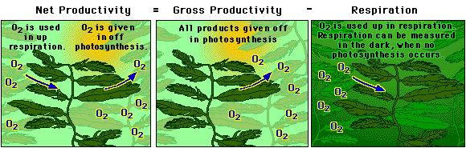

Primary productivity can be measured in three ways:
1. | The amount of carbon dioxide used
2. | The rate of sugar formation
3. | The rate of oxygen production

Dissolved Oxygen Availability
Oxygen is essential for cellular respiration in most organisms. In an aquatic environment, oxygen availability is influenced by a variety of chemical and physical factors.

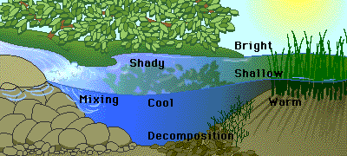
Some of the factors that affect the amount of oxygen dissolved in water are:
• | Temperature: As water becomes warmer, its ability to hold oxygen decreases.
• | Photosynthetic activity: In bright light, aquatic plants are able to produce more oxygen.
• | Decomposition activity: As organic material decays, microbial processes consume oxygen.
• | Mixing and turbulence: Wave action, waterfalls, and rapids all aerate water and increase the oxygen concentration.
• | Salinity: As water becomes more salty, its ability to hold oxygen decreases.

Sample Data and Analysis Questions:
- A water-sampling lab was measuring the dissolved oxygen in 7 bottles. Each bottle was capped and contained a suspension of unicellular algae and was placed in a lighted area. The light was passed through an aquarium to remove the heat to prevent destroying the algae. The initial DO was 4 mg/l. The bottles with their final DO levels are shown below.
  - What was the purpose of measuring the initial DO?
  - What is the purpose of the foil-covered bottle? Why is its dissolved oxygen below the initial DO?
  - What purpose do the screened bottles serve?
  - What level of screens represents a threshold where productivity balanced (or nearly balanced) respiration rate?
  - How is net productivity calculated using the bottles below?
  - How is gross productivity calculated using the bottles below?
  - How is the respiration rate calculated using the bottles below?
Foil-covered  1 mg/l | 8 screens  2 mg/l | 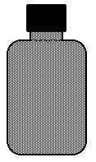  5 screens  4 mg/l | 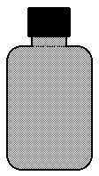  3 screens  5 mg/l | 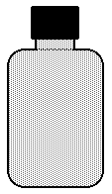  1 screen  10 mg/l | 0 screens  12 mg/l

2 The graph on the right represents data collected in productivity experiment of the same type of experiment that is depicted above. At what level of light percent is there no net productivity? At what light intensity is there no gross productivity? Explain. | 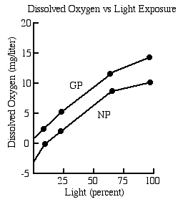
3   The graph to the right describes the relationship between dissolved oxygen and temperature. Describe the relationship and explain it. | 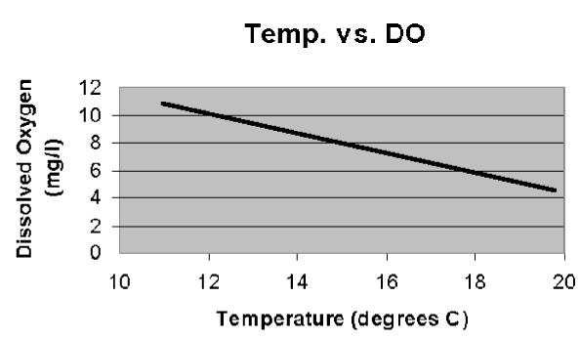

4  Two cultures are prepared in the lab as follows: one has little phytoplankton but is high in zooplankton, and has a low DO to start. The other is rich in phytoplankton and zooplankton, and has a high dissolved oxygen to start.  - Describe what should happen in the two bottles after 40 minutes of light exposure in the lab. Explain your description.  - Which should have the highest net productivity?  - Which should have the highest gross productivity?  - Which should have the highest respiration rate? | Bottle A Bottle B  Phytoplankton low high  Zooplankton high high  Initial DO low high

5. A class of APES students collected respiration rate data from BOD bottles using suspensions of unicellular freshwater algae. The class averages for the respiration found with the dark bottles is shown below.  Respiration Rate Table  Class Mean  Initial DO 4.0  Dark Bottle DO 3.1  A table to the right summarizes the data collection of one lab group. Calculate the GP and NP for each bottle.  Graph the data on the graph provided. What does the graph indicate about the productivity of the system in the bottles? | Class Mean  Productivity Data  # screens % light DO GP LB-DB NP LB-IB  0 100% 10.5  1 65% 8.9  3 25% 6.5  5 10% 5.9  8 2% 4.8 | 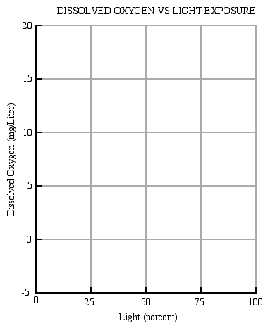

   In the diagram to the right, two containers hold fish and no algae. Which will maintain a higher DO over a 24 hour period? Explain. | 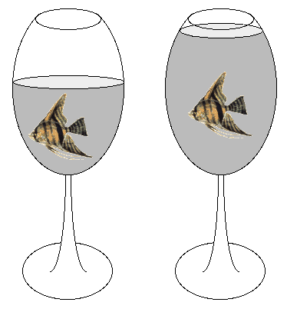
- In a outdoor pond over a 24 hour period, when would the DO be the highest? When would it be the lowest? Why?
- Explain why fertilizer runoff into a pond and the resulting eutrophication is an ecological problem for aquatic life in the pond.
- Explain why a mammal uses considerably less energy to ventilate gas in and out of its lungs while a fish uses much more.
- You must be able to use the nomogram below. If the water temperature is 25°C and saturated with oxygen, what is the concentration of the oxygen in the water?
  - 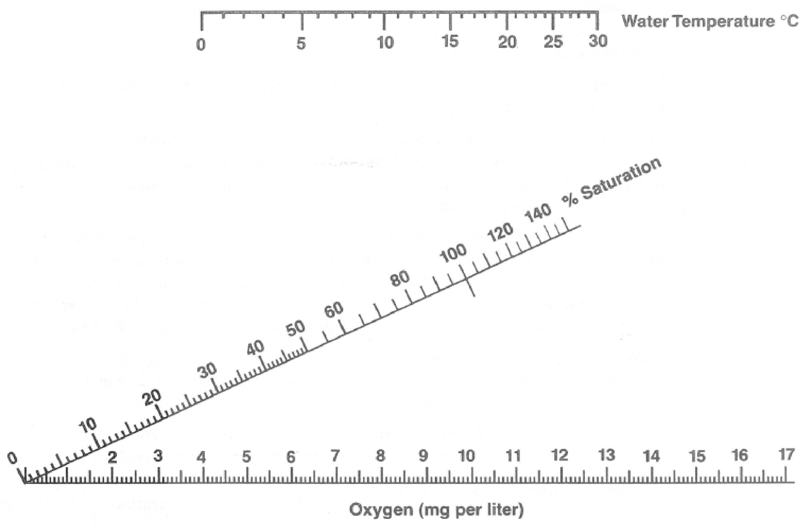
- If a student buys a bottled water that is 20% saturated with oxygen at 10°C, what happens to the oxygen saturation level as the bottle warms on his desk (without opening) before he drinks it?
Answers:

  - To find the starting oxygen concentration. Without it, we would not know how much oxygen was produced or consumed once the bottles were capped and the experiment was begun.
  - To find the respiration rate and thus be able to calculate the GPP of the algae in the suspension. Without photosynthesis, the only metabolic activity would be respiration or oxygen consumption.
  - The screens reduce the light influx into the bottles and thus allow controlled lowered light levels to strike the algae.
  - At 5 screens, the final oxygen concentration was 4 mg/l, which was the same as the starting concentration. With no net change, photosynthesis balanced respiration.
  - Net productivity is found by subtracting the initial bottle DO from the experimental bottle DO.
  - Gross productivity is found by subtracting the dark bottle DO from the experimental bottle DO.
  - The respiration rate is found by subtracting the dark bottle DO from the initial bottle DO.
- At about 10% light intensity, the dissolved oxygen is 0, which means that photosynthesis is balancing respiration
- As temperatures rise in a solution, the dissolved gases expand and some leave the solution. As they leave, their concentration in the solution falls.

  - Bottle A will have the lowest oxygen concentration, since it has a low phytoplankton population coupled with a high zooplankton population. It has little ability to produce oxygen but a high ability to use it. Bottle B will have a higher oxygen concentration, since it has more phytoplankton and a higher ability to produce oxygen.
  - Bottle B
  - Bottle B
  - Bottle B
- Graph the data as you did in your lab manual. The graph slope describes the ability of the system to produce oxygen, by photosynthetic activity
- The wine glass at the right will have the lowest DO over the 24 hour period. This is because its surface area in contact with air is much smaller than the glass on the left. With less surface area contact with air, it has less ability to gain oxygen, since neither bottle have algae to produce it.
- DO would be lowest just before dawn, when overnight respiration has used the greatest amount of pond oxygen. By 5 pm, DO is at its highest level, due to the activity of algal photosynthesis in the sun.
- The phosphates and nitrates in the fertilizer encourage the growth of algae, which increases the biological activity in every cubic meter of water. At dawn, excess microbial life in the water may consume ALL of the oxygen in the pond water and all multicellular life will suffocate.
- Gases pass through tubes much more easily than water, and air contains much more oxygen per unit volume than does water. Thus, fish work harder to get less oxygen than their terrestrial counterparts.
- Approximately 8.5 mg/l
- As water warms, the gases normally expand and leave the aqueous system. The bottle is sealed so the gases cannot leave. As a result, the water becomes more saturated with oxygen as it warms, and it may become a supersaturated solution if warmed sufficiently. This is why hot water draining from a tap in the winter is often cloudy - gases have reached supersaturation levels and immediately leave the solution when the water is exposed to air, making it appear cloudy.

