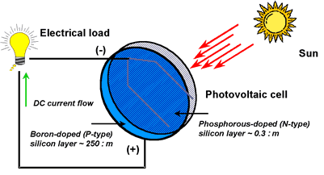

<http://www.youtube.com/watch?v=x2zjdtxrisc>

[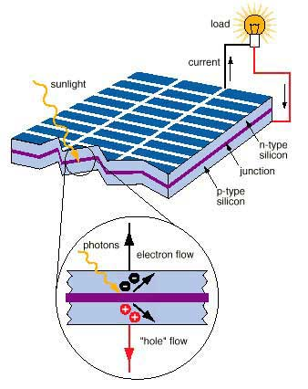](http://www.google.com/url?sa=i&rct=j&q=diagram+of+how+pv+cells+work&source=images&cd=&cad=rja&docid=enE9U6X3dVGWhM&tbnid=KHEn-SzX_8bdmM:&ved=0CAUQjRw&url=http://kids.actewagl.com.au/education/energy/RenewableEnergy/SolarEnergy/HowSolarCellsWork.aspx&ei=HlMZUfIB5_OJAunugIgJ&bvm=bv.42261806,d.cGE&psig=AFQjCNEl3vl-fZO4QaCfrEknr1XgTKmG6A&ust=1360700566164198)

[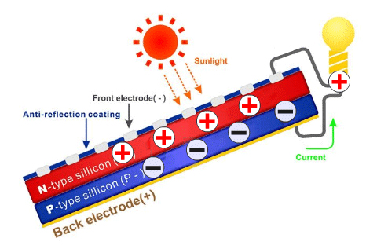](http://www.google.com/url?sa=i&rct=j&q=diagram+of+how+pv+cells+work&source=images&cd=&cad=rja&docid=awSVPbUGtIH-vM&tbnid=Ngdgj1jkLfoilM:&ved=0CAUQjRw&url=http://www.uksolargeneration.co.uk/pv_solar_technology.php&ei=c1MZUe-kI6ScjALQ2YGQBQ&bvm=bv.42261806,d.cGE&psig=AFQjCNHUuiUTWAEuGngcMbKwEnw-6yHNmg&ust=1360700631721987)

[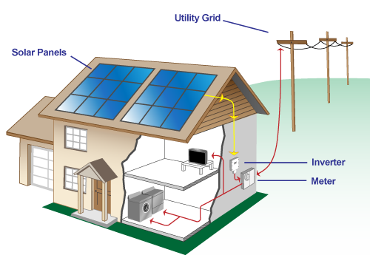](http://www.google.com/url?sa=i&rct=j&q=diagram+of+how+pv+cells+work&source=images&cd=&cad=rja&docid=1iJ7Mbjkjn6aiM&tbnid=tOHsAWxmhxmynM:&ved=0CAUQjRw&url=http://www.synsolar.com/howSolarWorks.php&ei=yFMZUcjPHYK_igLs7ICgDg&bvm=bv.42261806,d.cGE&psig=AFQjCNHUuiUTWAEuGngcMbKwEnw-6yHNmg&ust=1360700631721987)

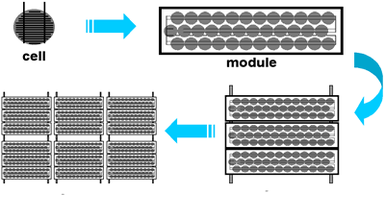

[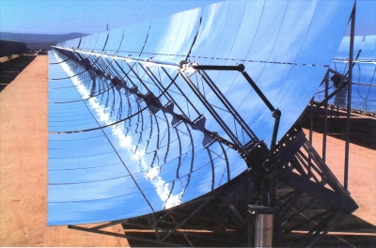](http://www.google.com/url?sa=i&rct=j&q=solar+thermal+concentrating+systems&source=images&cd=&cad=rja&docid=swgiXIehoLm3TM&tbnid=u57DrelTzileSM:&ved=0CAUQjRw&url=http://news.cnet.com/8301-11128_3-9951463-54.html&ei=UVYZUZW8FMS5igK3m4HADQ&bvm=bv.42261806,d.cGE&psig=AFQjCNFtFdXqFva3LgBFPSUNtR64eKlFPA&ust=1360701382863996)

[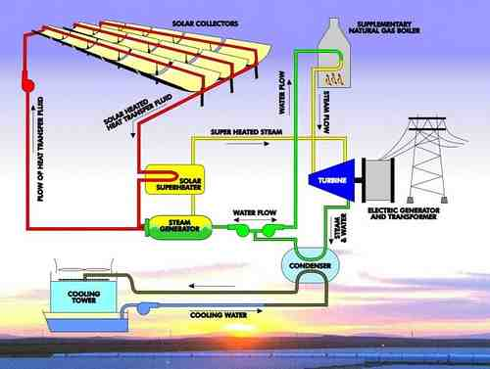](http://www.google.com/url?sa=i&rct=j&q=solar+thermal+concentrating+systems&source=images&cd=&cad=rja&docid=oK3a5cwoem_NDM&tbnid=nQOe0nW7dxoAcM:&ved=0CAUQjRw&url=http://www.zulenet.com/electriceco/CSP-Concentrating-Solar-Power.html&ei=ZlYZUZzjG6n0iwKNkIGoCA&bvm=bv.42261806,d.cGE&psig=AFQjCNFtFdXqFva3LgBFPSUNtR64eKlFPA&ust=1360701382863996)

<http://www.youtube.com/watch?v=rO5rUqeCFY4>