Name___________________________________
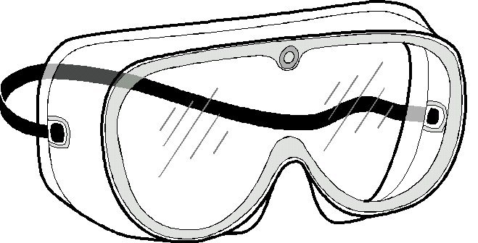 Goggles on around open flames

Problem: To simulate the changes that occur during the rock cycle

Materials: Sugar cubes, Candle, Test tube clamp, Foil, Hand lens, Goggles

Procedure
1. Examine the sugar cube with a hand lens. How is the sugar cube like
sedimentary rock?

2. Crush the sugar cube into a powder (in your hand or onto a piece of paper). What part of the rock cycle does this represent?

3. Make a “boat” with your foil. Pour the crushed sugar into the foil boat.
What part of the rock cycle does this movement represent?

4. Use the test tube clamp to hold the boat over the candle flame. Observe
as the sugar begins to melt. What part of the rock cycle does this
represent?

5. Set the foil boat aside and let the sugar cool and harden. What part of the
rock cycle does this represent?

6. Break the hardened sugar into pieces. What part of the rock cycle does
this represent?

Conclusion: Draw a model of the rock cycle using the sugar cube and the phases you caused it to go through. You can use drawings and/or words. Include arrows and label the process the arrows represent.

