Survivorship Curve
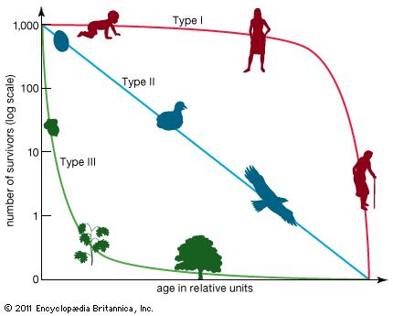
Characteristic | Type 1 | Type 2 | Type 3
Early age survivorship
Late age survivorship
Age reaching reproductive maturity
Brood size
Parental investment
Life span
Examples

Population Distribution
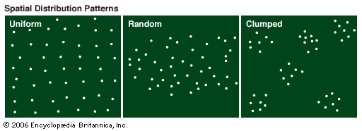
Type of Distribution | Description | Example
Uniform
Random
Clumped
Population Growth Curves
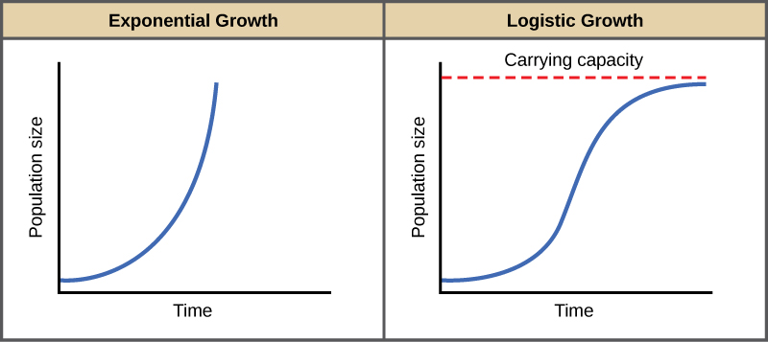
Growth Curve | Description | Environmental Conditions
Exponential

Logistic

