The Effect of Edge Habitat on Ecosystem Health

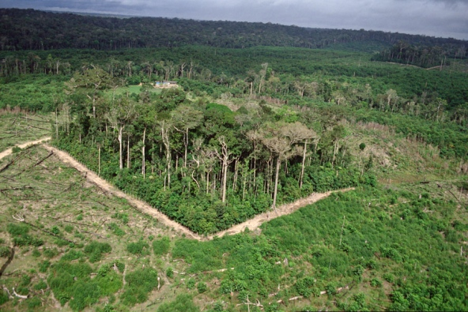
Introduction
As humans interact with the landscape, habitat loss and/or fragmentation is of increasing concern. Habitat fragmentation occurs when a larger, continuous environment is broken into smaller remnants. This may be caused urban development, commercial forestry, mining, agriculture, and other anthropogenic (human) activities. Natural processes such as wildfire and tornado may also fragment habitat.
When a landscape is divided, the edge habitat increases in area, while the interior environment decreases. Edge and interior habitats vary in their abiotic conditions, as the edge environment has higher light levels, higher temperatures, and lower soil moisture levels. As a result, the health of an ecosystem is often compromised when habitat fragmentation occurs. Specifically, habitat fragmentation causes a decline in biodiversity and population density, change in species composition and interactions, disruption to ecosystem functions, and an increase in invasive species and land-use activities. These changes may result in the ecosystem having less variety of food, breeding grounds, and shelter for a range of organisms. It may also result in the ecosystem being more prone to disturbance and less resilient to changes in the environment, leading to even greater change in the future.

Study Site
A comparison of edge and interior habitat plant species will take place along the Skyline Trail and Red Butte Canyon. The area is heavily used by hikers, runners, mountain bikers, and dog walkers. Two main regions have been identified: the area adjacent to the dirt road and the area along the Skyline Trail immediately to the South of the dirt road (Figure 1). The region along the dirt road is considered edge habitat because the road clearly breaks the tree canopy and separates the dominant vegetation into smaller pieces. Light levels and temperatures are noticeably greater in this area. The area off of the Skyline Trail is considered interior habitat because it is away from the edge created by the dirt road, has an intact canopy, and maintains a relatively continues environment. While the trail does separate the habitat slightly, the effects are thought to be minimal.

Student Objectives:
- Gather evidence to support/refute the ecological theory that increased fragmentation will negatively impact the ecosystem health.
- Use evidence gathered in study to explain the importance of biodiversity as it effects ecosystem interactions and health.
- Apply information learned from this study to make inferences of how future land-use patterns may impact ecosystem.

Line Transect Sampling Technique
Vegetation surveys will be conducted using a line-transect method. This is a tool used to determine the type and abundance of plant species in a given area. It allows scientist to consider small understory species and larger saplings, shrubs, and trees. In this method, the measuring “tape” is extended through the randomly selected area. The type and abundance of each plant species through which the tape crosses is recorded. This includes plants crossing above and below the measuring tape.

Procedure:
- Randomly assign locations for line transects.
  - Overlay polygon on sampling area using Google Earth.
  - Place grid in polygon. Assign a number to each square in grid.
  - Using a random number generator, identify 10 squares to sample within the larger sampling area (5 in edge habitat, 5 in interior habitat).
- Place transect
  - Begin transect at the NW corner of the randomly determined location.
  - Extend transect 10 m perpendicular to the edge.
  - Transect should be relatively strait. If a large object (e.g., tree) is in the path, place transect at its base, go around, and continue in approximately a straight line.
  - Secure tape by placing “nail” in soil
- Determine type and abundance of plant species
  - At each 0.25 m along transect, note the type of plant that is directly below or above the tape. (Note: the canopy of a tree may cross above the tape even though it’s trunk may not. This should be included in data collection.)
  - Type of plant should be recorded by specific plant name (e.g., Gambler oak, canyon maple, cheat grass) if it is known OR by generic name (plant A, plant B, plant C, etc.). Each plant species should be given a unique plant name.
  - Record the number of times each plant type is observed at each 0.25 m along transect.

10 m
Near Edge
Edge
Far from Edge
* Transect locations are determined randomly

Data Collection

Meta Data:

Temperature ____________________________ Precipitation ____________________________

Cloud Cover ____________________________ Elevation ____________________________

Other ( ) ____________________________ Other ( ) ____________________________

Edge Habitat:
Plant Species | Abundance | Invasive (Y/N) | Notes

Interior Habitat:
Plant Species | Abundance | Invasive (Y/N) | Notes

Analysis
- Calculate species diversity using Shannon Weiner Diversity Index
  - Formula:
    - H = -SUM[(pi) * ln(pi)]
    - Where, SUM = Summation pi= Numbe of individuals of species i/total number of samples S = Number of species or species richness
    - Results range from 1 to 4, with 4 having the greater diversity
- Calculate species evenness
  - Formula:
    - E=H/H_{max}
    - Where H_{max} = Maximum diversity possible
    - Results range from 0 to 1, with 1 having perfect evenness

Discussion
- Compare diversity and evenness between edge samples and interior samples.
- Compare percent invasive species between edge samples and interior samples.
- Explain the effect of edge habitat on species diversity.
- Discuss how edge habitat affects ecosystem diversity.
- Edge habitat species profile … link to food web dynamics…
- Considering the information learned regarding the relationship between edge habitat and ecosystem health, what recommendations can be made to land managers to promote a more sustainable ecosystem?
- Describe the “next steps” to be taken to further investigate this subject?

Reflection
- Consider today’s research experience. What went well? What would you do different in the future?

