APES book Review: The Emerald mile

Introduction
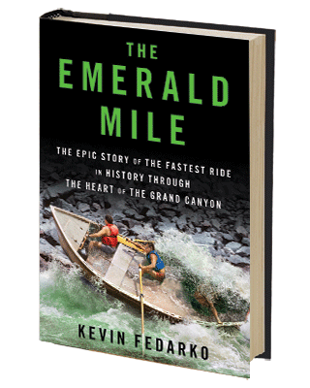
The Colorado River is the primary river flowing through the southwest of the U.S. It drains water from seven states, playing major roles in energy production, irrigation, and recreation. Throughout the AP Environmental Science course, you will consider the many interactions humans have on resources such as the Colorado River. Reading The Emerald Mile will serve as an excellent introduction to topics considered in this class.

Summary of the Book (from Amazon.com)
IN THE WINTER OF 1983, the largest El Niño event on record sent a chain of superstorms in from the Pacific Ocean to batter the entire West. That spring, a massive snowmelt sent runoff racing down the Colorado River toward the Glen Canyon Dam, a 710-foot-high wall of concrete that sat at the head of the most iconic landscape feature in America, the Grand Canyon. As the water clawed toward the parapet of the dam, worried federal officials desperately scrambled to avoid a worst-case scenario: one of the most dramatic dam failures in history.
Kenton Grua, a fearless boatman and the captain of the Emerald Mile, embarked on an unusual and defiant mission: to use the flooding dam's torrents of water as a hydraulic slingshot that would hurl him and two companions through 277 miles of some of the most ferocious white water in North America and, if everything went as planned, catapult theEmerald Mile into legend as the fastest boat ever propelled—by oar, by motor, or by the grace of God—through the heart of the Grand Canyon.

The Assignment
A. The Collection:
- Read the book.
- Annotate the book as you read.
- After reading the book, write an analysis that includes the following:

- Summary of book
- Connection to environmental Science
- Sides of the issue
- Environmental problems
- Possible solutions
- Your opinion

C. The Grade

 | 5 | 3 | 0
Annotations | Annotations included throughout the book are thoughtful, diverse, and demonstrate deep thinking that connects ideas. | Annotations included throughout the book are moderately thoughtful, diverse, and demonstrate deep thinking that connects ideas. | Annotations included throughout the book are minimally thoughtful, diverse, and demonstrate deep thinking that connects ideas.
Summary | Provides an accurate, detailed summary of the book, describes the individuals involved, and clearly explains the environmental issue. | Provides a partial summary of the book, description of the individuals involved, and an explanation of the environmental issue. Lacks some detail and accuracy. | Does not accurately summarize the book, the individuals involved, or the environmental issue.
Connection to Environmental Science | Clearly explains how the issue described in the book relates to environmental science. | Partially explains how the issue described in the book relates to environmental science. | Does not explain how the issue described in the book relates to environmental science.
Sides of the Issue | Describes all relevant sides of the environmental issue without bias. | Describes some of the relevant sides of the environmental issue without bias. | Does not describe the relevant sides of the environmental issue.
Solutions & Problems | Describes in detail the proposed solutions to the problem &/or predicts complications associated with the issue. | Describes some of the proposed solutions to the problem &/or predicts complications associated with the issue. | Does not describe proposed solutions to the problem &/or predict complications associated with the issue.
Opinion | Presents personal opinion about the environmental issue, controversy surrounding the issue, possible solutions, and potential complications. | Presents some personal opinion about the environmental issue, controversy surrounding the issue, possible solutions, and potential complications. | Does not present personal opinion about the environmental issue, controversy surrounding the issue, possible solutions, and potential complications.
TOTAL

