Arizona Enlists a Beetle in Its Campaign for Water
By KEN BELSONJULY 14, 2014
Photo
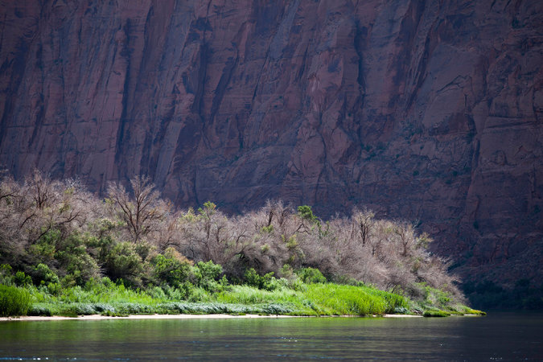
Tamarisk trees at Glen Canyon in Arizona. The trees consume considerable water, which has made them a target for farmers, ranchers and water authorities. CreditSamantha Sais for The New York Times

LEES FERRY, Ariz. — In this corner of America known for its vast landscapes, rugged mountains and deep river canyons, signs of the havoc created by the minuscule tamarisk beetle are everywhere.
For miles along the banks of the Colorado River, hundreds of once hardy tamarisk trees — also known as salt cedars — are gray and withered. Their parched branches look like victims of fire or drought.
But this is not the story of beloved trees being ravaged by an invasive pest — quite the opposite. Farmers, ranchers and the water authorities here are eager to get rid of the tamarisk trees, which are not native to Arizona and which they say suck too much water.
They have welcomed the beetles, which have made their way from Colorado and Utah over the last decade, and have watched with delight as the centimeter-long workhorses have damaged the trees by eating their spindly leaves. The hope is that the beetles will now rid Arizona of the trees.
“We view the tamarisk as a pest,” said Joseph Sigg, the government relations director at the Arizona Farm Bureau. “Water is an expensive input, and to the extent that we can lower it, the beetle can help.”
Photo
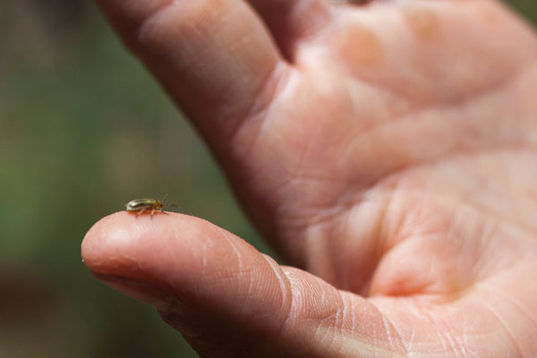
Tamarisk beetles were released in Colorado about a decade ago and have now moved to Arizona, where officials hope they will stop the spread of the tamarisk tree. The tree consumes considerable water. CreditSamantha Sais for The New York Times
But scientists say that nature is rarely a zero-sum game, and that removing the deep-rooted tamarisks — which the authorities have tried with bulldozers, chain saws and now beetles — will not produce more water. New tamarisks or other trees will replace the fallen ones, the scientists say, and the birds that live in the tamarisks, like the endangered Southwestern willow flycatcher, will be harmed. Plus, once the beetles are done eating tamarisk leaves, they are likely to feed on other trees.
Better to view replacing the tamarisk as a way to increase biodiversity, not save water, they said.
“It’s one of the paradoxes of the tamarisk: There are worse alternatives,” said Kelly Burke, the executive director of the Grand Canyon Wildlands Council, which removed acres of tamarisk along the Colorado River and replaced them with native trees like cottonwoods and willows. “Usually at the core of it is a simplistic equation that public officials and community leaders get in their head.”
The debate about eliminating the tamarisk as a way to save water has thrust the beetle into a wider debate about the unintended consequences of trying to repair an environment that humans have altered dramatically over the years.
Since they first settled the West, Americans have fought a never-ending battle to find and conserve water to support people living in an inhospitable desert, even if the financial and ecological costs were high.
In June, the Central Arizona Project, which manages the 336-mile water system that carries water from the Colorado River to Arizona’s cities, said deliveries to Phoenix and Tucson might be cut by the end of the decade if water consumption was not reduced. Lake Mead, a Colorado River reservoir that is the network’s sole water source, fell this month to a level not seen since the lake was filled in 1938.
Ruinous droughts and rapid population growth in recent years have strained the state’s vulnerable water supply and heightened the scramble to find new solutions, from desalination to cloud seeding to vegetation management, which includes eliminating the tamarisk.
The tree has been an easy scapegoat.
Photo
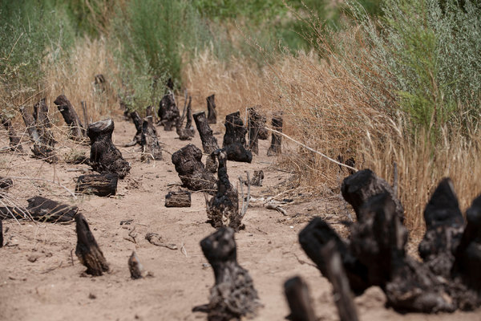
Blackened tamarisk stumps in Glen Canyon. People have used bulldozers, chain saws, beetles and other tools to get rid of the thirsty tamarisk trees. CreditSamantha Sais for The New York Times
The tamarisk, which lives in Asia and the Middle East, was imported more than a century ago to prevent erosion. With a dense and sprawling network of roots and an ability to thrive in arid terrain, the tree did that job well.
But as rivers were dammed, riverbanks receded, starving many native trees and pushing out the insects, birds and other wildlife that relied on them. In their place, the tamarisk took over.
Advocates of removing the tamarisk claim that a mature tree can consume more than 200 gallons of water a day. That has tantalized farmers and utilities in search of cheap, plentiful water.
David Modeer, general manager for the Central Arizona Project, the wholesale provider of water from the Colorado River, said that the declining flow of water in rivers was due largely to climate change and drought. While removing every tamarisk is not practical, he said, it does make sense to get rid of the trees in places where they crowd out native habitat.
“We’re all looking at ways to increase the flows from the Colorado,” he said. “Every drop counts.”
There is little proof, though, that removing the tamarisk will increase the amount of available water. And if thirstier trees replace it, there could be even less water.
While the beetle appears to be efficient at defoliating tamarisk trees, it works on its own schedule, which is why the tree is still often removed manually. It is a costly and imperfect process.
Ms. Burke of the Grand Canyon Wildlands Council said that 15 people spent 10 days cutting tamarisks from a six-acre slice of shoreline nine miles downriver from the Glen Canyon Dam. They applied Garlon, a herbicide, to the stumps, and the fallen trees were burned.
Photo
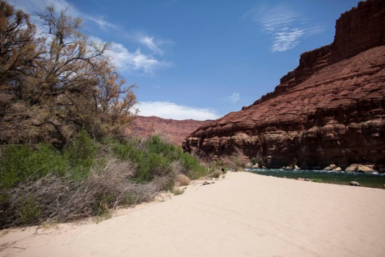
Tamarisk trees were imported more than a century ago to prevent erosion. Advocates of removing them claim that a mature tree can consume more than 200 gallons of water a day.CreditSamantha Sais for The New York Times
Yet nearly five years later, tamarisk saplings have sprouted next to the blackened stumps, a reminder of how difficult it is to remove a tree that produces hundreds of millions of seeds.
“You’ll never get the last tree,” said Gibney Siemion, an ecologist with the Grand Canyon Wildlands Council, which spent about $24,000 to remove the trees. “You do your best, but the tamarisk is very adaptable.”
To save money and avoid the constant culling, the United States Department of Agriculture studied how to introduce the tamarisk beetle, the tree’s natural predator. About a decade ago, the first beetles were released in Colorado, and despite predictions that they would move slowly, they have arrived in Northern Arizona sooner than expected.
The beetles are likely to reach the southern parts of Arizona in about two years, said Stacy Beaugh, executive director of the Tamarisk Coalition, which restores riversides. “It hasn’t been overnight, but it’s been much faster than expected,” she said.
On this stretch of the Colorado River near the Grand Canyon National Park, the beetles’ handiwork is evident: Many tamarisks are brown or gray, denuded of their leaves. But the trees’ roots are so dense that it may take several seasons before they die, Ms. Siemion said.
The cottonwoods, willows and other native vegetation the council planted, however, have turned a patch of land once thick with tamarisk into a lush, green refuge from the heat.
Manual efforts like this have taken place across the West. Two years ago, in Phoenix, the city’s Water Services Department and the Army Corps of Engineers removed tamarisk along 1,920 acres of the Salt River as part of a $200 million flood control and wetlands restoration project.
The river is barely a trickle, but, on one side of it, tamarisk that ran 50 yards up from the river were cleared and replaced with willow and cottonwood trees, as well as cattails and other plants. The opposite riverbank, which abuts the Gila River Indian Reservation, is still thick with tamarisk.
“You cut out tamarisk, plant native species and build a canopy so the tamarisk don’t come back,” said Robert F. Upham, an engineer with the City of Phoenix who has worked on the project. “The idea was to have nature take care of nature.”
Preventing the tamarisk from encroaching again, though, will take constant attention, which belies the notion that removing the tree will somehow solve Arizona’s water woes.
“There’s this sense that we’re looking for villains and someone to blame,” said Melissa Sevigny, who has written about the tamarisk for the online journal Terrain. “The tough thing is to turn it around and look at ourselves as the ones who have taken too much from these landscapes. It’s so much easier to point fingers.”

