Comparative Anatomy: The Skeletal System
Many of the structures highlighted in the comparative anatomy skeletal drawings exemplify homologous structures. These are anatomical features that are similar in structure but have evolved notable differences over time as a species has adapted to better survive in a specific environment. Studying homologous structures can provide information about how an environment has influenced as species’ anatomy and evolution.

Observe the humerus, radius, ulna, carpals, metacarpals, phelanges in each of the skeletal system drawings. Identify similarities and differences between these structures.
Describe the collective function(s) of this group of bones in each of the species below.
Species | Function
Human
Pig
Pigeon
Frog

Modification of structures arise when variations in structures are more successful in a specific environment than others. Predict how the environment may have influenced the evolution of these homologous bones in each of the following species.
Species | Function
Human
Pig
Pigeon
Frog
Homologous structures provide evidence that different species have evolved from a common ancestor. This can be depicted in a phylogenetic tree.

What do you think is meant by common ancestor?

Examine the phylogenetic tree below. Explain how the similarities and differences observed in the different species’ skeletal systems support the phylogeny below. Provide specific examples for the skeletal system drawings to support your response.

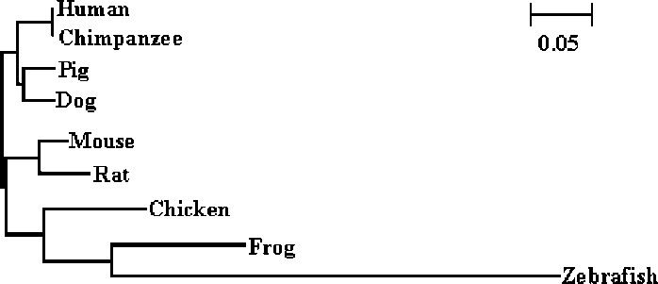

Add any species to the phylogenetic tree that are not included above. Explain why you predict they would be placed there. Support your explanation with evidence from the skeletal system drawings.

