APES Country Project
E. Moretz, 2013/2014

In a galaxy far, far away, on the planet of P.O.T.A., lives a population of curious life forms known as APES. P.O.T.A. is sending APES representatives to the distant planet of Earth to explore the possibility of establishing future settlements. As a P.O.T.A. delegate, you have been tasked with traveling to this planet to conduct a thorough evaluation of a specific country. P.O.T.A. has assigned you to work with a small group of representatives to research and present a detailed description of the conditions found within three distinct nations. Your mission details follow. Live long and prosper.
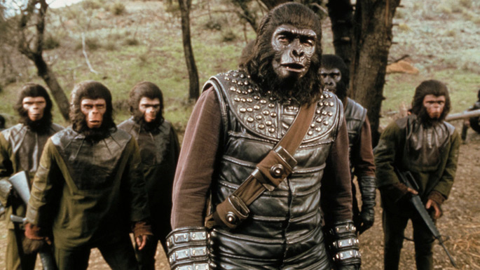

Objective: To research and present an in-depth description of the environmental, social, economic, and political aspects of a specific country.

Directions: Research the topics listed below for the assigned country. Create a publication or presentation for this information and present your findings to the class. Your document must include all of the following information.

Countries:

Canada
China
D.R. of Congo

Germany
India
Haiti

Japan
Brazil
Nigeria

Norway
Mexico
Bangladesh

Research Components:
Part 1 (Due _______):
- Physical Environment – describe each item listed below and provide appropriate maps, graphs, and pictures to enrich your description.
  - Geographic location
  - Tectonic activity
  - Topography
  - Soil profile
  - Water resources
  - Common rock types
  - Major ocean currents
  - Major wind patterns
  - Important meteorological events
  - Biome(s)

- Living Environment – describe each item listed below and provide appropriate pictures and diagrams of the organisms and their ecological relationships.
  - Invasive species (2)
  - Endangered species (2)
  - Keystone species (1)
  - Producer-consumer relationship (2)
  - Predator-prey relationship (2)
  - Symbiotic relationship (1)
  - Interspecific competition relationship (1)
  - Food Web (1)
  - Government incentives/regulations – discuss specific ways in which the government supports conservation efforts

Part 2 (Due _______):
- Population – describe each item listed below and provide appropriate graphs, data, and pictures to support your explanation
  - Age-structure diagram
  - Forecasted demography for 2050.
  - Demographic transition phase
  - Total fertility rate
  - Family planning methods
  - Crude birth rate
  - Crude death rate
  - Infant and child mortality rate
  - Urbanization patterns
  - GDP PPP
  - Primary sources of employment
  - Recent/current civil unrest (war)
  - Government incentives/regulations - discuss specific ways in which the government supports family planning efforts
  - Health concerns - describe the illnesses and associated causes, effects, and solutions.

- Land Resources – describe each item listed below by discussing the specific resources being consumed as well as the methods used to access these resources. Provide appropriate pictures and graphs to support your explanation
  - Major national parks (2)
  - Agricultural resources
    - Farming
    - Rangelands
    - Fishing
    - Pesticide use
  - Forest resources
  - Mineral resources
  - Government incentives/regulations - discuss specific ways in which the government supports land use practices.

Part 3 (Due _______):
- Energy – describe each item listed below by discussing the energy sources, ways of accessing these resources, and the pros and cons of using such resources. Include appropriate pictures, maps, and graphs to support your explanation.
  - Non-renewable energy source(s)
  - Alternative fuel source(s)
  - Government incentives/regulations – discuss specific ways in which the government supports acquisition and utilization of energy resources.
  - Health concerns - describe the illnesses and associated causes, effects, and solutions.

Part 4 (Due _______):
- Pollution – describe each item listed below by discussing the major sources of pollution, causes/sources of pollution, affects of pollution (environmental, economic, & health), and possible solutions to reduce each source of pollution. Include appropriate pictures, graphs, and maps to support your explanation.
  - Water pollution
  - Air pollution
  - Noise &/or light pollution
  - Government incentives/regulations to decrease pollution - discuss specific ways government efforts to mitigate pollution.
  - Health concerns - describe the illnesses and associated causes, effects, and solutions.

- Global Change – describe each item listed below and discuss specific causes, effects, and solutions. Include appropriate graphs, maps, and pictures to support your explanation.
  - Biodiversity
  - Acid Deposition
  - Climate Change
  - Ozone Depletion
  - Government incentives/regulations - discuss specific ways government efforts to mitigate these environmental problems.
  - Health concerns - describe the illnesses and associated causes, effects, and solutions.

- Health – discuss major health concerns by Include appropriate graphs and pictures to support your response.
  - Health concerns - These may be illnesses caused by pollution, ecological disasters, employment hazards, etc. and may be linked to topics discussed in previous sections.
  - Government incentives/regulations to improve human health - discuss specific government efforts to improve human health.

