It Takes Teamwork: How Endosymbiosis Changed Life on Earth
by the Understanding Evolution team ; adapted from http://evolution.berkeley.edu/evolibrary/article/0_0_0/endosymbiosis_01
In 1966, microbiologist Kwang Jeon was studying single-celled organisms called amoebae, when his amoebae communities were struck by an unexpected plague: a bacterial infection. Literally thousands of the tiny invaders — named x-bacteria by Jeon — squeezed inside each amoeba cell, causing the cell to become dangerously sick. Only a few amoebae survived the epidemic.
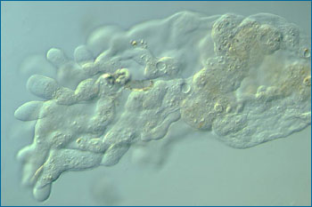
The blob-like form of an amoeba
However, several months later, the few surviving amoebae and their descendents seemed to be unexpectedly healthy. Had the amoebae finally managed to fight off the x-bacterial infection? Jeon and his colleagues were surprised to find that the answer was no — the x-bacteria were still thriving inside their amoebae hosts, but they no longer made the amoebae sick. There were more surprises when Jeon used antibiotics to kill the bacteria inside an amoeba — the host amoeba also died! The amoebae could no longer live without their former attackers. Jeon discovered that this was because the bacteria make a protein that the amoebae need to survive. The nature of the relationship between the two species had changed entirely: from attack and defense to cooperation.
In this case study we will explore these key questions:
- What is endosymbiosis?
- What role did endosymbiosis play in the evolution of eukaryotes?
- How does endosymbiosis change our view of the branching pattern on the tree of life?

When two become one
Jeon's colonies of amoebae seem perfectly happy living with their permanent guests, the x-bacteria, inside of them. This kind of relationship — two or more different species living in close association — is called symbiosis.
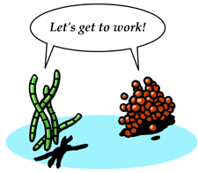
Each amoeba and its x-bacteria work together for mutual benefit — but they are still separate organisms. Each bacterium or amoeba divides on its own, gets its own energy, uses its own genes, and makes its own proteins (mostly!). However, with their close relationship, it seems possible that after many years of evolving together, these cells could become not just a team, but a single integrated organism with a common set of genes and proteins. A future scientist discovering the descendents of Jeon's amoebae might not guess that this one "amoebacterium" was once two distinct organisms.
Evidence like this points to the likelihood that the "merging" of two simple organisms has also happened under natural conditions. Long ago in evolutionary history, two cells formed a symbiotic team that, over millions of years, evolved into a single organism. The result of this union was the first eukaryotic cell — the type of cell that makes up the human body. We humans owe our existence to two bacteria that teamed up in a symbiotic relationship over a billion years ago!
3 kinds of symbiosis:
mutualism
a symbiosis in which both organisms benefit
commensalism
a symbiosis in which one organism benefits without helping or harming the other
parasitism
a symbiosis in which one organism benefits at the expense of the other

From prokaryotes to eukaryotes
Living things have evolved into three large clusters of closely related organisms, called "domains": Archaea, Bacteria, and Eukaryota. Archaea and Bacteria are small, relatively simple cells surrounded by a membrane and a cell wall, with a circular strand of DNA containing their genes. They are called prokaryotes.
Virtually all the life we see each day — including plants and animals — belongs to the third domain, Eukaryota. Eukaryotic cells are more complex than prokaryotes, and the DNA is linear and found within a nucleus. Eukaryotic cells boast their own personal "power plants", called mitochondria. These tiny organelles in the cell not only produce chemical energy, but also hold the key to understanding the evolution of the eukaryotic cell.

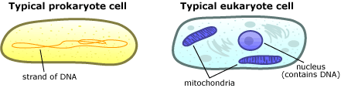
The complex eukaryotic cell ushered in a whole new era for life on Earth, because these cells evolved into multicellular organisms. But how did the eukaryotic cell itself evolve? How did a humble bacterium make this evolutionary leap from a simple prokaryotic cell to a more complex eukaryotic cell? The answer seems to be symbiosis — in other words, teamwork.
Evidence supports the idea that eukaryotic cells are actually the descendents of separate prokaryotic cells that joined together in a symbiotic union. In fact, the mitochondrion itself seems to be the "great-great-great-great-great-great-great-great-great granddaughter" of a free-living bacterium that was engulfed by another cell, perhaps as a meal, and ended up staying as a sort of permanent houseguest. The host cell profited from the chemical energy the mitochondrion produced, and the mitochondrion benefited from the protected, nutrient-rich environment surrounding it. This kind of "internal" symbiosis — one organism taking up permanent residence inside another and eventually evolving into a single lineage — is called endosymbiosis.
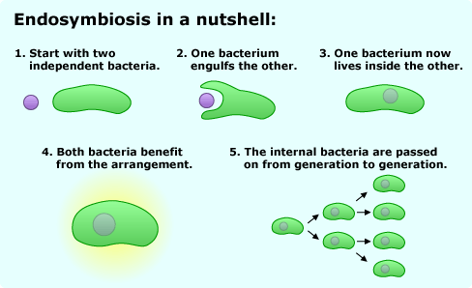
Evidence for endosymbiosis
Biologist Lynn Margulis first made the case for endosymbiosis in the 1960s, but for many years other biologists were skeptical. Although Jeon watched his amoebae become infected with the x-bacteria and then evolve to depend upon them, no one was around over a billion years ago to observe the events of endosymbiosis. Why should we think that a mitochondrion used to be a free-living organism in its own right? It turns out that many lines of evidence support this idea. Most important are the many striking similarities between prokaryotes (like bacteria) and mitochondria:
- Membranes — Mitochondria have their own cell membranes, just like a prokaryotic cell does.
- DNA — Each mitochondrion has its own circular DNA genome, like a bacteria's genome, but much smaller. This DNA is passed from a mitochondrion to its offspring and is separate from the "host" cell's genome in the nucleus.
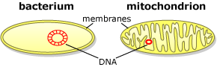
- Reproduction — Mitochondria multiply by pinching in half — the same process used by bacteria. Every new mitochondrion must be produced from a parent mitochondrion in this way; if a cell's mitochondria are removed, it can't build new ones from scratch.
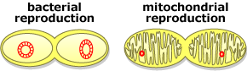
When you look at it this way, mitochondria really resemble tiny bacteria making their livings inside eukaryotic cells! Based on decades of accumulated evidence, the scientific community supports Margulis's ideas: endosymbiosis is the best explanation for the evolution of the eukaryotic cell.
What's more, the evidence for endosymbiosis applies not only to mitochondria, but to other cellular organelles as well. Chloroplasts are like tiny green factories within plant cells that help convert energy from sunlight into sugars, and they have many similarities to mitochondria. The evidence suggests that these chloroplast organelles were also once free-living bacteria.
The endosymbiotic event that generated mitochondria must have happened early in the history of eukaryotes, because all eukaryotes have them. Then, later, a similar event brought chloroplasts into some eukaryotic cells, creating the lineage that led to plants.
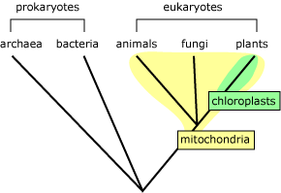
Despite their many similarities, mitochondria (and chloroplasts) aren't free-living bacteria anymore. The first eukaryotic cell evolved more than a billion years ago. Since then, these organelles have become completely dependent on their host cells. For example, many of the key proteins needed by the mitochondrion are imported from the rest of the cell. Sometime during their long-standing relationship, the genes that code for these proteins were transferred from the mitochondrion to its host's genome. Scientists consider this mixing of genomes to be the irreversible step at which the two independent organisms become a single individual.

Finding our roots
Many aspects of endosymbiosis still aren't understood. For example, how did the first endosymbiont get inside its host? Was the host trying to eat the endosymbiont? If so, why wasn't the endosymbiont digested? Or was the endosymbiont trying to infect and exploit the host, the way the x-bacteria originally invaded their amoebae hosts?
We might get closer to answering these questions if we knew what species of bacteria came together to make the original eukaryotic cell. Biologists are in the process of figuring this out using evidence provided by comparing the gene sequences of different organisms. In general, the more similar two organisms' genes are, the more recently their two lineages split apart from one another. If two organisms have been evolving separately for a very long time, and have a distant common ancestor, they are likely to have evolved lots of differences between their gene sequences. So by comparing the genetic sequences of different organisms, biologists can piece together their family tree — who is related to whom.
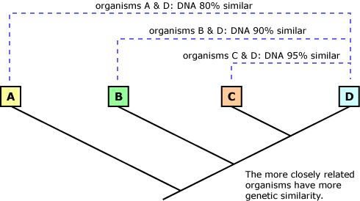
Biologists have even studied the DNA in mitochondria to figure out how they are related to free-living bacteria. These studies have shown, first, that all mitochondria are descended from one original mitochondrion — that is, endosymbiosis of a mitochondrion only happened once — and second, that mitochondria are most closely related to a bacteria called Rickettsia prowazekii. This parasitic bacterium causes epidemic typhus and is primarily transmitted through bites of animals such as fleas.
As DNA sequencing projects decode more genomes letter by letter, we are learning that eukaryotic "host" cells have a lot in common, genomically speaking, with the strangest, least-understood domain of life: the Archaea. These prokaryotes went completely undiscovered until 1977 because they live in such extreme environments as Antarctica, the Dead Sea, deep-sea vents, hot springs, and sewage sludge. Yet one of them may have been the first endosymbiotic host, and our own ancestor.

How important is endosymbiosis?
Endosymbiosis explains the origin of mitochondria and chloroplasts, but could it also explain other features of the eukaryotic cell? Maybe. Endosymbiotic origins have been suggested for many structures, including flagella (structures like the tail of a sperm), cilia (hair-like structures that help in locomotion), and even the nucleus — the cell's command center! However, scientists are still actively debating whether or not these structures evolved through endosymbiosis. The jury is out while more evidence is gathered.
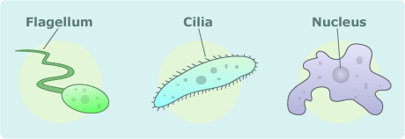
In her theory of endosymbiosis, Lynn Margulis emphasizes that during the history of life, symbiosis has played a role not just once or twice, but over and over again. Instead of the traditional tree of life branching out from a few common ancestors to many descendent species, Margulis proposes that branches have separated, and then come together again many times as individuals of different species set up symbiotic relationships and formed new organisms. This process formed an interconnected tree of life in which organisms have multiple ancestors, even from different domains. As eukaryotes, our ancestors include both the bacteria that became mitochondria, and the archaebacterium that was the host cell.
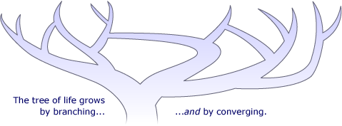
Why have endosymbiosis and symbiosis been so important to evolution? Why cooperate at all? The answer to these questions points us to one of the basic processes of evolution: natural selection. As Darwin observed, organisms that are fit enough to succeed in the game of survival have a good chance of passing on their genes to the next generation. Any survival or reproductive advantage can help a species out-compete another species or simply avoid becoming extinct itself. It seems likely that the first eukaryotic cells gained a slight edge over their neighbors when the mitochondria, a rich source of energy, moved in with them. Like Kwang Jeon's x-bacteria and amoebae, the mitochondria and their hosts relied more and more on each other in order to survive. Eventually, neither could succeed alone — but as a team they produced millions of descendants, establishing a whole new domain of life.

