Interdependent Relationships
  - An ecological Tour of Latin & South America
Biology, 2018/2019

Introduction
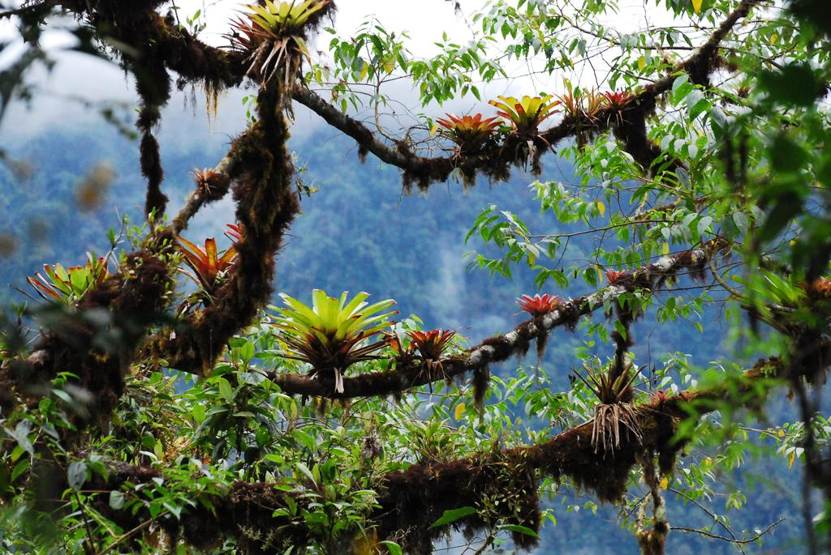The Earth is home to many diverse ecosystems consisting of interdependent relationships between biotic and abiotic factors. Understanding the specific ecology of a region is useful in appreciating past, present, and future environmental concerns, as well as the societal, cultural, political, and economic elements of that country. In this project, you will become an expert of the environment of your assigned country by studying the community and population ecology of that area and designing an informative ecotourism pamphlet.

Directions
Create an ecotourism brochure for your assigned country by researching the topics listed below. Your brochure should be written for a 6th grade, non-academic audience and contain many graphics (e.g., maps, graphs, illustrations) to support and enhance the text.

Research Topics, Guiding Questions, & Subtopics

Energy Flow – How is ENergy transferred through an ecosystem?
  - Food web & components
  - Ecological pyramids (biomass, numbers, energy)

Ecological relationships – What are the Ecological relationships present in an Ecosystem?
  - Producer-consumer
  - Predator-prey
  - Symbiosis
  - Ecological niche & competition (interspecific & intraspecific)

Biodiversity – How diverse is the community and what factors are influencing its biodiversity?
  - Invasive species
  - Endangered species

Population growth – How is the human population changing over time?
  - Human population growth patterns (2010, 2018, 2025, 2050)
  - Demographic patterns
  - Urbanization patterns

Cycles – How are nutrients cycled throughout an ecosystem and what factors are affecting them?
  - Carbon cycle
  - Nitrogen cycle
  - Water cycle

Human Impact – What role(s) do Humans have in influencing the ecosystem?
  - Land & energy resources (e.g., national parks, agriculture, mining, forestry, fishing, mining)
  - Major ecological concerns (causes, effects, solutions)
  - Ecological policies/regulations/legislation/incentives
  - Ecotourism activity

Rubric
Project Element | Student Assessment | Teacher Assessment
Completion: All research components are included, submitted on time, and display a high quality of work. |  | /10
Collaboration: All team members work together in a respectful manner, contributing equally to the research process and pamphlet production. |  | /10
Content: All research components are accurately and thoroughly explained in a clear and concise manner.  - Food web & components  - Ecological pyramids  - Producer-consumer  - Predator-prey  - Symbiosis  - Competition & niche  - Biodiversity  - Invasive species  - Endangered species  - Human growth patterns  - Demographic patterns  - Urbanization  - C cycle  - N cycle  - Water cycle  - Land & energy resources  - Ecological concerns  - Ecological policies/regulations/legislation/incentives  - Ecotourism activity |  | /100
Graphics: Each research component includes appropriate and meaningful visuals to enhance understanding  - e.g., maps, pictures, diagrams, graphs, tables |  | /30
Communication: Each research component is explained to the audience in a clear and engaging manner. |  | /10
Display: The format of the project is such that it promotes audience understanding and engagement. |  | /10
Citations: The source of each research component is cited in the text and in a bibliography. |  | /10
Total |  | /180

The Details…

Food Web
- Food web that represents the feeding relationships common to an ecosystem of the selected country.
- Identification of autotrophs and heterotrophs including herbivores, omnivores, carnivores, scavengers, and decomposers.
- Identification of the trophic levels in the food web.
- Identification of the primary producers and various consumers (primary through tertiary).
- Discussion of a scenario (relevant to past or present) that could (or has) led to a collapse of the food web, what the impact(s) are/were of that change, and possible solutions to this scenario.

Ecological Pyramids
- Select a food chain within the food web for which an ecological pyramid can be created.
- Design an ecological pyramid that accurately reflects the relationship between trophic levels for energy, biomass, or numbers.
- Include a written explanation that describes the flow of energy, biomass, or numbers between trophic levels, as shown in the diagram.

Ecological Relationships
- Within the food web, include at least one notable example of each of the major ecological relationships.
  - Producer-consumer
  - Predator-prey
  - Symbiosis
    - Parasitism
    - Mutualism
    - Commensalism
  - Interspecific competition
- Include a written statement that identifies the type of relationship, the organisms involved in that relationship, and how these organisms affect each other.
- For the predator/prey relationship, create a graph that illustrates how the predator and prey populations affect each other over time.

Biodiversity
- Describe the relative biodiversity of your ecosystem.
- Discuss major factors influencing the country’s biodiversity.
- Identify at least one invasive species present in the country. If applicable, add the species to the food web. For the selected invasive species:
  - Image of species
  - Scientific name
  - Cause(s) for the species’ introduction
  - Description of harm caused by species’ presence
  - Map(s) of native range/distribution in comparison to present range/distribution
  - Solutions to remove the population for the ecosystem.

- Identify at least one endangered species whose population is declining. If applicable, add the species to the food web. For the selected endangered species, discuss the following:
  - Image of species
  - Scientific name
  - Causes for the species’ decline
  - Map(s) of current range/distribution in comparison to historical range
  - “Value” of species in the ecosystem
  - Solutions to increase the populations’ success.

Populations
- Illustrate and summarize the human growth patterns in your country over time.
  - Include information for the following years: 2010, 2018, 2025, 2050.
  - These can be shown with age structure diagrams and a discussion of the change in populations over time.
- Describe the demographic patterns for your country.
  - This should include a minimum of 5 of the following:
    - age, sex, educational level, income level, marital status, occupation, birth/date rate, infant mortality, life expectancy, total fertility rate, etc.
- Describe the urbanization patterns of the country.
  - Discuss the percent of the population living in rural, suburban, and urban areas; the future trends in urbanization; and what demographic(s) are inhabiting different urban/rural settings.

Human Impact
- Identify the primary resources utilized by humans (e.g., specific mineral resources, agriculture, mining).
  - Be specific by including percentages, locations, and impacts on the environment.
- Identify protected ecological areas, such as national parks.
  - Include maps of the reserves.
- Describe major ecological concerns of the country.
  - What are the concerns, what is/are the cause(s), what is/are the impact(s).
  - Include pictures and maps, if applicable.
- Identify and describe important ecological policies, regulations, legislation, and incentives.
- Identify ecotourism activities of the country.

