August 25, 2015
National Space Agency  101 Satellite Ave., N.W.  Washington D.C., 20002  Tel 801-867-5309  alien@nationalspaceagency.org  www.nationalspaceagency.org | 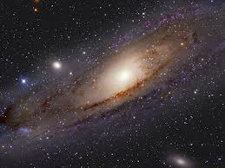

SLCSE Biologists
1400 West Goodwin Ave.
Salt Lake City, UT 84116
Dear Biologists,
It has come to my attention that you are science students who are beginning an extensive study of the features and needs of living things, and can conduct some experiments relating to materials which might be living or nonliving. I understand that you are able to determine carbon dioxide production, make cell population counts, measure growth, observe respiration rates and so forth.
In my position as director of the agency, I have been authorized to ask for your help with a most pressing matter. We have recently received samples from space and must determine if they are living or nonliving. We would be most appreciative if you would, in your cooperative lab groups, perform tests to make this determination. We will expect you to conduct multiple lab investigations for each specimen to determine if they meet several of the characteristics of life. Submit your draft experimental designs and request necessary material to your teacher for approval. We will remain in contact with your teacher and she will convey our further directions to you.
In anticipation of your helping us with this most important task, we have forwarded the samples to your school. We look forward to your reports of your success and thank you for your help.
Sincerely yours,
Alfred P. Aerosmith, Director

