Plant Anatomy Lab

Objectives
- To identify the structures of the plant that supports the process of photosynthesis through laboratory observations.
- To determine the function of the structures of the plant that supports the process of photosynthesis through laboratory observations.
- To explore factors that influence the process of photosynthesis by designing, implementing, and analyzing a controlled experiment.

Introduction
Photosynthesis is the metabolic process in which light energy is captured by the pigment, chlorophyll, in plant tissues, combined with carbon dioxide and water, and converted into oxygen and glucose (sugar). The equation below represents this chemical reaction (figure 1).
Figure 1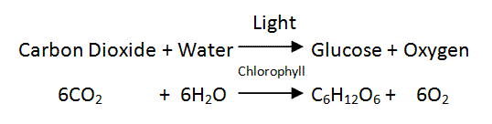

A variety of plant tissues are needed to support photosynthesis. Gas exchange occurs through pores, or stomata (figure 2), usually located in the epidermis of a plant’s leaves. Water is transported upward in a plant from the roots to the stem through a type of vascular tissue called xylem (figure 3). The glucose produced in photosynthesis is carried from the leaves to the rest of the plant through another type of vascular tissue called phloem (figure 3).

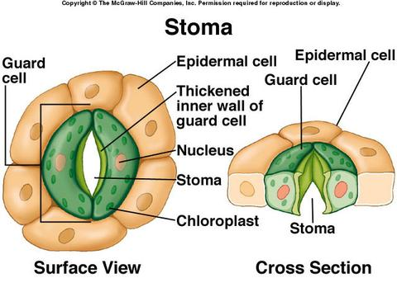
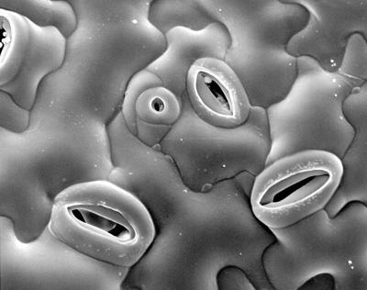

Figure 2
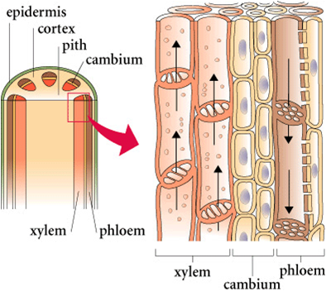
Figure 3

The process of photosynthesis is critical to the health of a plant and in turn the health of an ecosystem. Understanding the structures and functions involved in this biological process is critical to fully appreciating how the process is carried out in the plant, as well as how factors in the environment can positively or negatively influence the process. In this lab, students will examine the anatomy of plant structures involved in photosynthesis, determine how their structure influences their function, and explore the way in which a specific environmental factor impacts the process of photosynthesis.

Materials
Food coloring

Scalpel/razor blade
25 mL beakers
Ring stands
Test-tube clamp
Prepared slides
Microscopes
Hand lens
Beets
Carrots
Basil
Brussel sprouts
Potato
Clover
Celery
Labquest
Biochamber
Tulips
Lemongrass
Celery
Microscopes
Spinach leaves
Filter paper
Isopropyl alcohol
CO₂ and O₂ probes

Part A: Roots
In this station, you will observe the structure and determine the function of the roots of a plant. You will examine 4 specimens, including the roots of a 1) beet, 2) carrot, 3) potato, and 4) clover.

- Examine each of the 4 whole specimens with a hand lens. What similarities and differences do you notice between the specimens? Record your observations.
  - Similarities:

  - Differences:

- Based upon your observations, predict the functions of a root.

- Obtain a beet or a carrot root. Using a hand lens, look for very small, hair-like structures at the tip of the root. What do you notice? What do you think the function of the root hair is? What role do you think it plays in photosynthesis?
  - Observations (picture or words):

  - Function of root hairs:

  - Role in photosynthesis:

- Obtain a carrot root. Make a longitudinal cut through the length of the carrot. Using a hand lens, observe both the xylem and phloem in the root. Make a sketch of your observations.
  - Observations:

  - Function of xylem and phloem:

  - Role in photosynthesis:

Part B: Root slide
In this station, you will observe the structure and determine the function of the roots of a plant. You will examine a prepared slide of a root tip and root hairs.

- Examine the prepared slide of a root tip and root hairs. Study them under 4x and 10x magnification. Locate the xylem and phloem in each slide.

- Make a sketch of your observations, labeling the xylem and phloem.

- Explain how your observations confirm the role xylem and phloem play in the plant root.

- Explain how the structure of xylem and phloem observed in the root support the process of photosynthesis. Refer to your observations to support your explanation.

Part C: Stem observations
In this station, you will observe the structure and determine the function of the stem of a plant. You will examine 3 specimens, including the stems of 1) lemongrass, 2) celery, and 3) a tulip.
- Examine each of the 3 specimens with a hand lens. What similarities and differences do you notice between the specimens? Record your observations.
  - Similarities:

  - Differences:

- Based upon your observations, predict the functions of a stem.

- Obtain a piece of celery. Make a cross-section of the celery stalk. Observe the cut end of the cross-section with a hand lens. What do you notice? Make a sketch of your observations. What do you think the function of these structures is?
  - Sketch:

  - Prediction of function:

  - Role in photosynthesis:

Part D: Stem slide observations
In this station, you will observe the structure and determine the function of the stem of a plant. You will examine prepared slides of the stems of a monocot and a dicot plant.

- Examine the prepared slides of the stem of a monocot and dicot. Study them under 4x and 10x magnification. Locate the xylem and phloem in each slide.

- Make a sketch of your observations of one of the slides, labeling the xylem and phloem.

- Explain how your observations confirm the role xylem and phloem play in the plant stem.

- Explain how the structure of xylem and phloem observed in the stem support the process of photosynthesis. Refer to your observations to support your explanation.

Part E: Visualizing the Vascular Tissue
- As a group, obtain a single tulip. Describe the appearance of the tulip’s stem and flower in the table below.
- Make one longitudinal section of the tulip stem that is approximately 1 inch long.
- Fill two 25 mL beakers ¾ full with water. Place 3 drops of different food coloring into the respective beakers.
- Place one piece of the stem in one color and the other part of the stem in the other beaker of colored water. If necessary, support your flower with a test tube clamp and ring stand.
- Form a prediction as to how the tulip will/will not change over a 30 minute time period. Record your prediction in the table below.
- Leave the tulip in the colored water for 60 minutes. After the time as elapsed, examine the tulip again, noting any differences in appearance. Record your observations in the table below.

Prediction:

Pre-Observations: | Post-Observations:

- Discuss how the behavior demonstrated by the tulip stem supports the structure and function of vascular tissue in the stem of a plant. Refer to your observations to support your explanation.

Part F: Leaves
In this station, you will observe the structure and determine the function of the leaves of a plant. You will examine 7 specimens, including the leaves of 1) a fir tree, 2) an aspen tree, 3) a Christmas cactus, 4) onion, 5) basil, 6) brussel sprouts.
- Examine each of the 6 specimens with a hand lens. What similarities and differences do you notice between the specimens? Record your observations.
  - Similarities:

  - Differences:

- Based upon your observations, predict the functions of a leaf.

Part G: Leaf Slide Observations
In this station, you will observe the structure and determine the function of the leaf of a plant. You will examine a slide of Elodea and prepared slides of the leaves of a monocot and a dicot plant.

- Obtain a sample of Elodea leaf. Place the Elodea leaf on a slide with a drop of water. Observe the leaf under 4x and 10x magnification. Locate the nucleus and chloroplasts. Make a sketch (labeled) of your observations.

- Explain how your observations support the role that leaves play in photosynthesis. Refer to your observations to support your response.

- Examine the leaf slides of a monocot and dicot. Study them under 4x and 10x magnification. Locate the xylem and phloem in each slide.

- Make a sketch of your observations, labeling the xylem and phloem.

- Explain how your observations confirm the role xylem and phloem play in the plant leaf.

- Explain how the structure of xylem and phloem observed in the leaf support the process of photosynthesis. Refer to your observations to support your explanation.

Part H: Stomata Observations
This station will allow you to visualize the structure of the stomata found on the surface of a leaf. You will make an imprint of the epidermis of a leaf with nail polish and observe the stoma underneath a microscope.
- Obtain a leaf from a Christmas cactus plant.
- Paint a patch of clear nail polish on the leaf surface being studied. Make a patch at least one square centimeter.
- Allow the nail polish to dry completely.
- Tape a piece of clear cellophane tape to the dried nail polish patch.
- Gently peel the nail polish patch from the leaf by pulling on a corner of the tape and peeling the fingernail polish off the leaf. This is the leaf impression you will examine. (Only make one leaf impression on each side of the leaf, especially if the leaf is going to be left on a live plant.)
- Tape your peeled impression to a very clean microscope slide. Use scissors to trim away any excess tape.
- Make a sketch of your observations. Label the stoma and guard cells.

- Predict how the structure of stomata support the process of photosynthesis. Refer to your observations to support your prediction.

Part I: Chromotography of Plant Pigments
For photosynthesis to transform light energy from the sun into chemical energy (bond energy) in plants, the pigment molecules absorb light to power the chemical reactions. Plant pigments are macromolecules produced by the plant, and these pigments absorb specified wavelengths of visible light to provide the energy required for photosynthesis. Chlorophyll is necessary for photosynthesis, but accessory pigments collect and transfer energy to chlorophyll. Although pigments absorb light, the wavelengths of light that are not absorbed by the plant pigments are reflected back to the eye. The reflected wavelengths are the colors we see in observing the plant. (Example: green pigments reflect green light) Plants contain different pigments, and some of the pigments observed include:
- chlorophylls (greens)
- carotenoids (yellow, orange red)
- anthocyanins (red to blue, depending on pH)
- betalains (red or yellow)

The process of chromatography separates molecules because of the different solubilities of the molecules in a selected solvent. In paper chromatography, paper marked with an unknown, such as plant extract, is placed in a developing chamber with a specified solvent. The solvent carries the dissolved pigments as it moves up the paper. The pigments are carried at different rates because they are not equally soluble. A pigment that is the most soluble will travel the greatest distance and a pigment that is less soluble will move a shorter distance. The distance the pigment travels is unique for that pigment in set conditions and is used to identify the pigment. The ratio is the Rf (retention factor) value. Standards are available for comparison below.

Procedure:

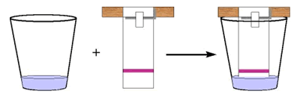

- Cut a strip of filter paper paper 1 X 9.5 cm. so that it fits inside the test tube. Cut a point in the bottom 0.5 cm of the strip.
- Draw a horizontal line with a pencil (not pen) about half an inch from the bottom.
- Tear a spinach leaf into very small pieces. Place them into a mortar along with a pinch or two of sand to help with grinding. Add about 5 ml ethyl alcohol to the leaf pieces. Crush leaves with the pestle, using a circular motion, until the mixture is finely ground. The pigment extract is now ready for paper chromatography.
- Use a glass rod to touch a small drop of the pigment extract to the center of the pencil line on the paper strip. Let dry. Repeat as many as 10 times, to build up the pigment dot. NOTE: It is important that the dot is dry before another drop is added. This keeps the pigment dot from spreading out.
- Pour 1.5 mL of isopropanol in the test tube.
- Tape the top of the coffee filter strip to a pencil and balance the pencil across the top of the test tube. See the image below for the set-up.
- It is very important that the bottom of the filter strip is in the isopropanol, but the green spot is not in the liquid. If the isopropanol touches the spot directly, the pigment will just dissolve away.
- Set the cup aside. The isopropanol will move up the filter paper slowly and deposit the pigment components along the way.
- Measure the distance from the fist pencil line to the solvent front. Record in the data below.
- Measure the distance from the first pencil line to the average peak of each color band. Record in the data table below.
- Calculate the Rf value for each pigment. The Rf is the and is calculated by:
Rf = distance pigment travels
Distance solvent front travels

Band Color | Plant Pigment | Distance (mm) | Rf
Yellow to Yellow-orange | Carotene
Yellow | Xanthophyll
Bright Green to Blue Green | Chlorophyll a
Yellow Green to Olive Green | Chlorophyll b

- Describe the pigments found in the spinach leaf.

- Explain how the chromatography investigation adds support to the role that chloroplasts plays in photosynthesis. Refer to your data to support your discussion.

- Predict how the results of the chromatography investigation would differ if pigments were extracted from an aspen leaf in the fall. Include a rationalization for your prediction.

Part J: Investigating Photosynthesis

Photosynthesis is influenced by a variety of environmental factors, which may impact the productivity and diversity of an ecosystem. At this station, you will identify one environmental factor that they think will influence the rate of photosynthesis. You will then design and sketch the experimental procedure, making use of the experimental design graphic organizer. At a later date, you will conduct the experiment and analyze their results. When designing the experiment, you will have access to spinach leaves, growth chambers, CO₂ and O₂ probes, and labquests for data analysis.

