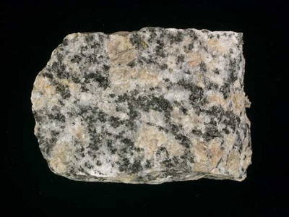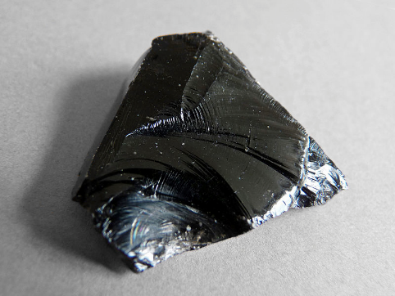

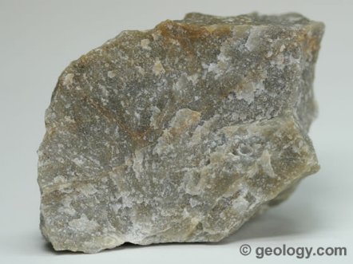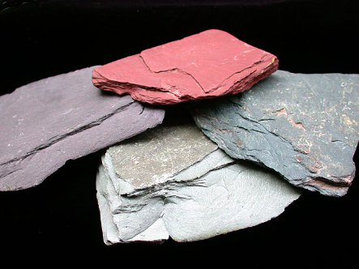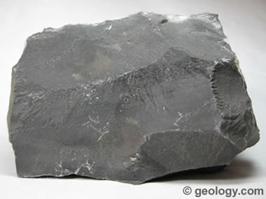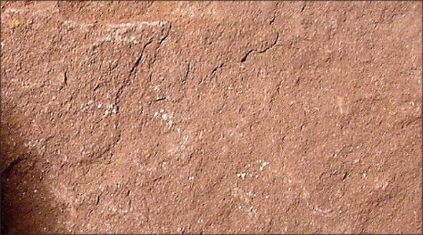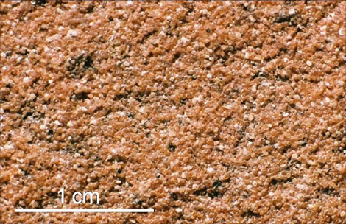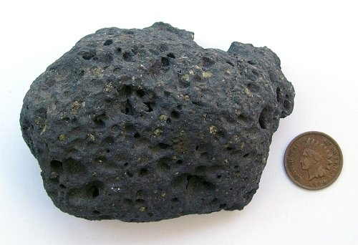Rock Cycle Guide Book

The rock cycle is an important process to understand because…

*Introduction*

During the rock cycle…

Types of Igneous rock:

Basalt

Granite

Obsidian

*Igneous Rock*

*Sedimentary Rock*

Types of Sedimentary rock:

Sandstone

Siltstone

Limestone

Bituminous Coal

Types of Metamorphic rock:

Slate

Quartzite

Anthracite Coal

*Metamorphic Rock*