Example #1

SEA ANEMONES AND HERMIT CRABS
Sea anemones (Calliactus spp) hitchhike on the back of hermit crabs, scoring a ride across the seabed and extending their tentacles to eat the crab’s leftovers. Crabs actively recruit these passengers. After poking an anemone with its pincers – causing it to release its grip from its current home – the crab holds it in place so the anemone can reattach to the crab’s own shell.
In return, the anemones fend off hungry octopuses and other predators using their barbed tentacles. The crabs return the favor by driving away creatures that eat anemones, such as starfish and fireworms.
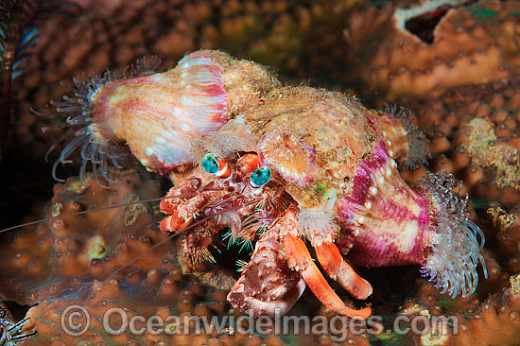

Example #2

GOBY FISH AND SNAPPING SHRIMP
Danger! That’s what the frantically flapping tail of a goby fish says to the near-blind snapping shrimp (Alfeus spp). In a crafty collaboration, snapping shrimps construct and maintain burrows in the seabed, while the fish stands guard. During construction, shrimps leave the burrow to deposit excavated sand.
Throughout this hazardous venture, shrimps maintain constant contact with their gobies using their antennae. In some cases, gobies even hover above their shrimp, allowing it to take its load further from the burrow’s entrance. Sighting potential threats, the fish waggles its tail against the shrimps’ antennae or into the burrow entrance, warning the shrimp of the danger. In return, the fish can call the burrow home, sleeping in it with the shrimp at night and using it as a convenient bolthole in the face of peril.
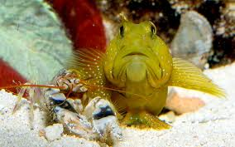

Example #3

AFRICAN OXPECKERS
African oxpeckers (Buphagus africanus and Buphagus erythrorhynchus) feed on the backs of zebra, elephants, hippopotamuses and other large African animals. Once thought to be friendly tick-eating helpers, they’re actually vampire birds, sucking blood out of open tick-wounds. This shows how the line between symbiotic assistant and parasite can be blurred. Oxpeckers do eat ticks as well, and some animals may be happy to sacrifice a bit of blood for this service. Oxpeckers may also be tolerated because they produce a hissing scream when startled – like a personal danger alarm.

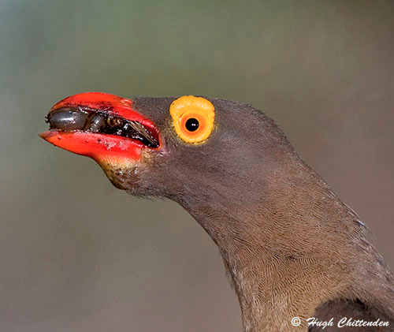

Example #4

CORAL AND ALGAE
Corals have a fairly easy life: they just sit back and let specially adapted algae make much of their energy for them. The algae live in the coral, feasting on waste products. Crucially, the algae can photosynthesize, using sunlight to turn carbon dioxide into sugars. After taking what it needs, the algae produces a little extra sugar for the coral. Completing the cycle, carbon dioxide from the coral is used by the algae.
The partnership may be the coral’s undoing however: worldwide, many species are losing their algae due to climate change. In a process called ‘coral bleaching’, algae are ejected when the temperature gets too warm, leaving ghostly-white reefs of dead coral in its wake.
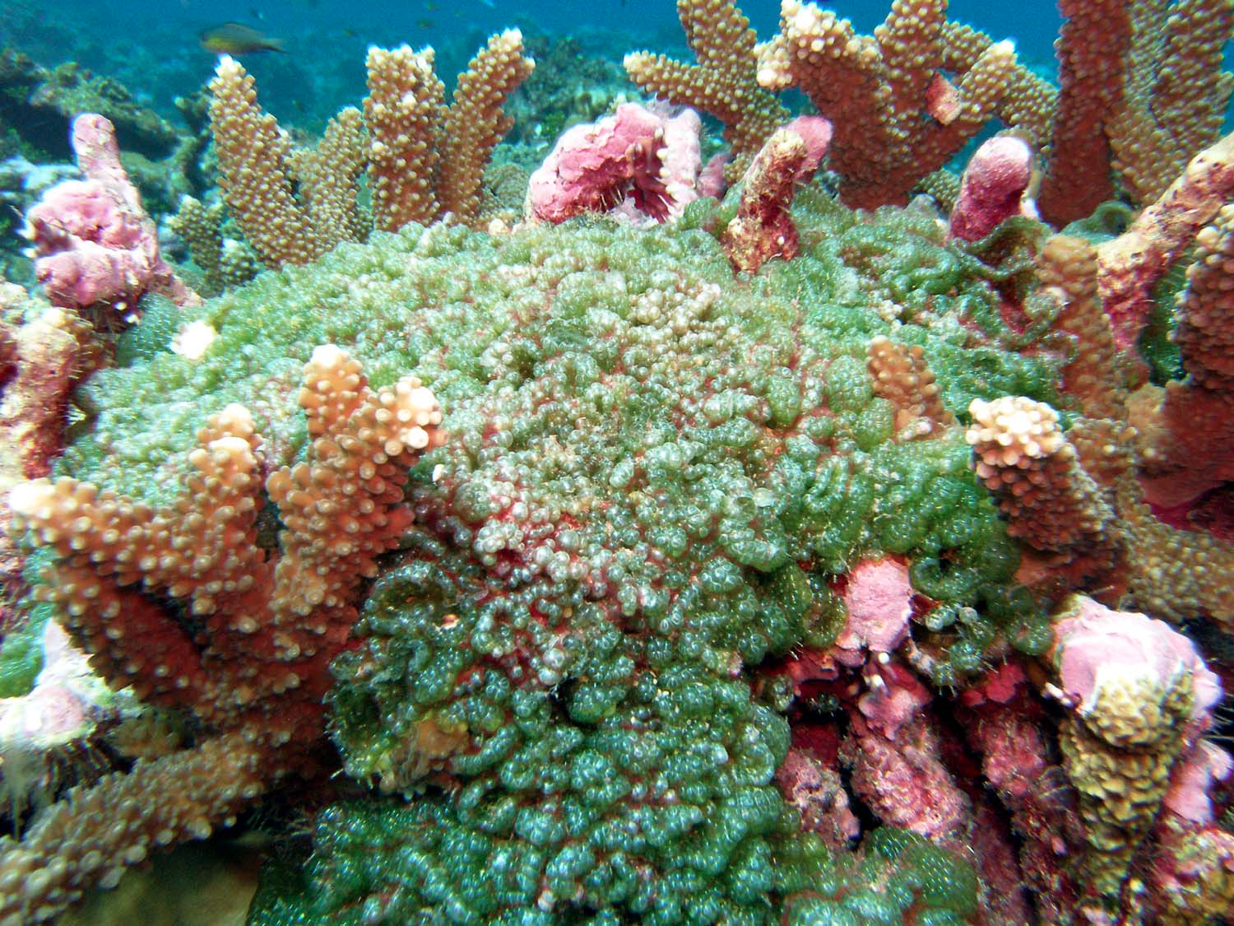

Example #5

BEES AND ORCHIDS
Male orchid bees (also known as Euglossine bees) collect perfume from a wide variety of South- and Central American neotropical orchids, and turn this into chemical signals called pheromones. It’s a messy procedure, which involves scraping brush-like foreleg tips all over orchid flowers before transferring the heady scent to storage sacs on the back legs.
In the process, orchid pollen is conveniently attached to the bee’s back, where it can subsequently rub off onto female parts of other flowers. The process is vital for orchid reproduction. Scientists aren’t yet sure what orchid bees do with their perfume-based pheromones. The potent concoction may attract females, be used to mark territories, or it may just smell awfully good
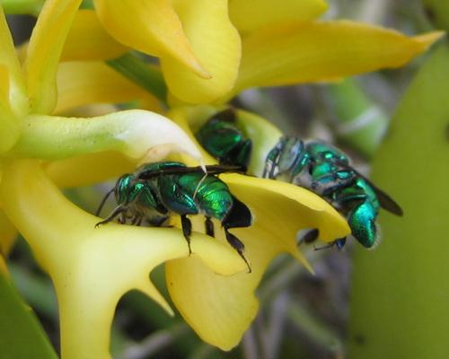

Example #6

Barnacles and Whales:
Barnacles adhering to the skin of a whale or shell of a mollusk: Barnacles are crustaceans whose adults are sedentary. The motile larvae find a suitable surface and then undergo a metamorphosis to the sedentary form. The barnacle benefits by finding a habitat where nutrients are available. (In the case of lodging on the living organism, the barnacle is transported to new sources of food.) The presence of barnacle populations does not appear to hamper or enhance the survival of the animals carrying them.

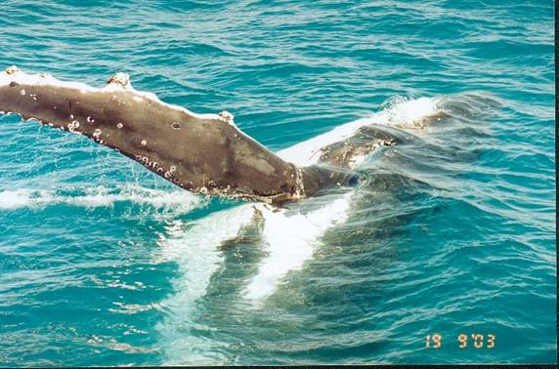

Example #7

Remora sharks and Whales:
Remora sharks are endowed with an adhesive disk on the dorsal surface of their heads. They use this adhesive disk to “hitch a ride” on larger animals, usually whales, which tend to be sloppy eaters. When food floats away from the whale’s mouth, the remora can unhitch itself and collect the scraps of food floating by.

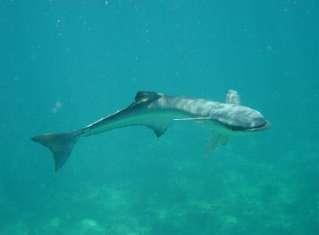

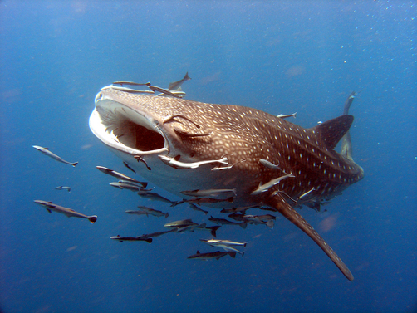
Example #8

HOOKWORM
This is a widespread disease in warm, tropical and sub-tropical places, especially where sewage disposal is inadequate. It is common in the Kimberley and other parts of tropical northern Australia. The adult worm is about 1 cm in length and is about the thickness of a pin. The worms suck blood from the human host. The disease becomes serious when there are many worms in the intestine sucking blood from the host. When this happens, the host loses too much blood which contains the body's important nutrients (nourishing food). This can cause:
- the body to become anaemic (pale and weak)
- fever
- diarrhoea or constipation
In extreme cases hookworm infestation can stop the person from thinking and moving properly. It can also slow down children's growth.
To get rid of these worms from the body, the person must be treated with special medicine.

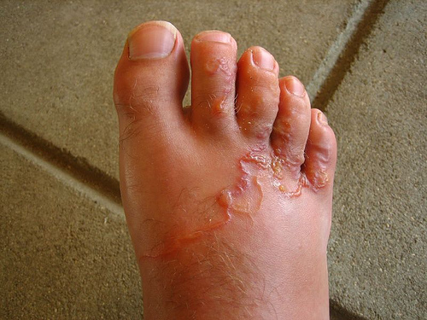
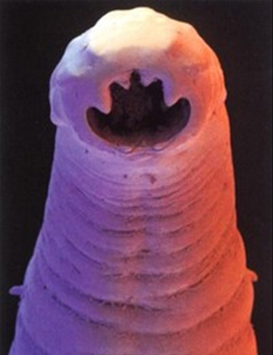

Example #9

Giardia lamblia:
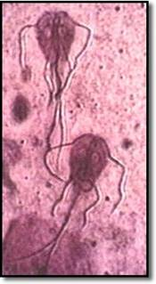
Giardia occur in the intestines of humans. When Giardia are inside the body they can move about quite easily, but they often leave the body as tiny egg-like cysts in faeces. Infection happens when these cysts are taken back into the body of someone who does not have Giardia in their intestines. Once inside the intestine they become mobile (able to move) again and start to reproduce themselves by dividing and redividing.
Giardia cysts can be passed:
- directly by the faecal/oral route from an infected person to one who is not infected
- indirectly by taking in the cysts in contaminated water or food when eating or drinking

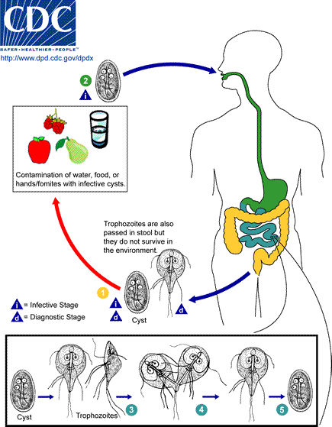
Example #10

TAPEWORM:
Tapeworm infection is caused by ingesting food or water contaminated with tapeworm eggs or larvae. If you ingest certain tapeworm eggs, they can migrate outside your intestines and form larval cysts in body tissues and organs (invasive infection). If you ingest tapeworm larvae, however, they develop into adult tapeworms in your intestines (intestinal infection). An adult tapeworm consists of a head, neck and chain of segments called proglottids. When you have an intestinal tapeworm infection, the tapeworm head adheres to the intestine wall, and the proglottids grow and produce eggs. Adult tapeworms can live for up to 20 years in a host. Intestinal tapeworm infections are usually mild, but invasive larval infections can cause serious complications.
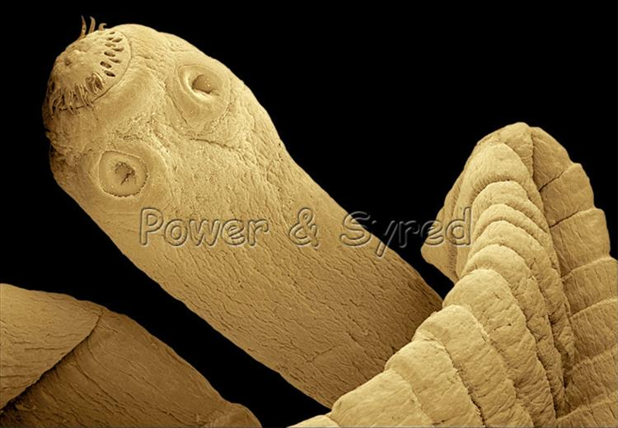
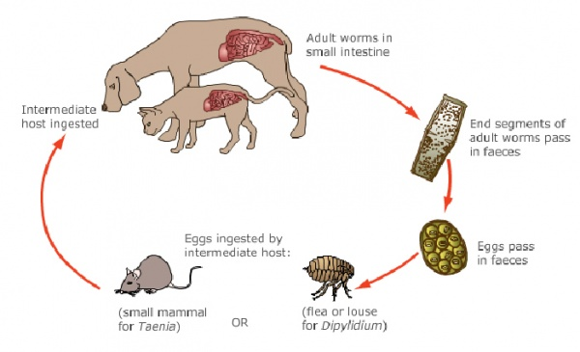

Example #11

Cattle egrets and Cattle:
Cattle egrets foraging in fields among cattle or other livestock. As cattle, horses, and other livestock graze on the field, they cause movements that stir up various insects. As the insects are stirred up, the cattle egrets following the livestock catch and feed upon them. The egrets benefit from this relationship because the livestock have helped them find their meals, while the livestock are typically unaffected by it.
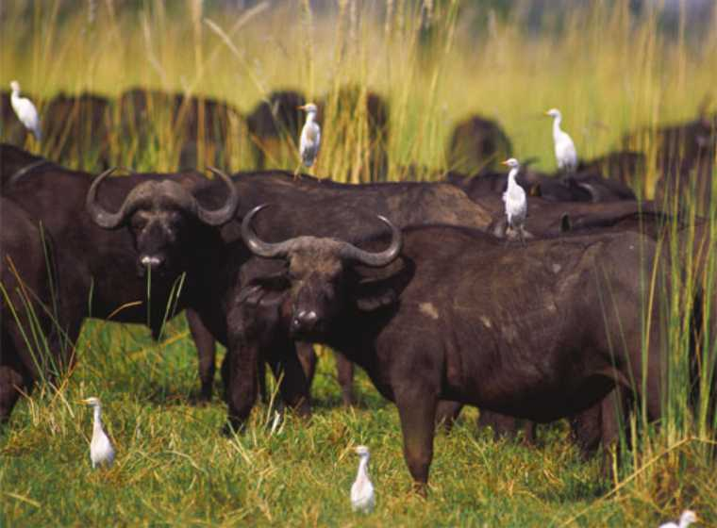

Example #12

Golden Jackals
In India, lone golden jackals expelled from their pack have been known to form symbiotic relationships with tigers. These solitary jackals, known as kol-bahl, will attach themselves to a particular tiger, trailing it at a safe distance in order to feed on the big cat's kills. A kol-bahl will even alert a tiger to a kill with a loud pheal. Tigers have been known to tolerate these jackals: one report describes how a jackal confidently walked in and out between three tigers walking together a few feet away from each other.^{[1]} Tigers will however kill jackals on occasion: the now extinct tigers of the Amu Darya region were known to eat jackals frequently.

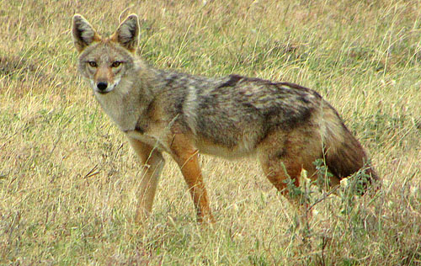

Example #13

Nitrogen Fixation:
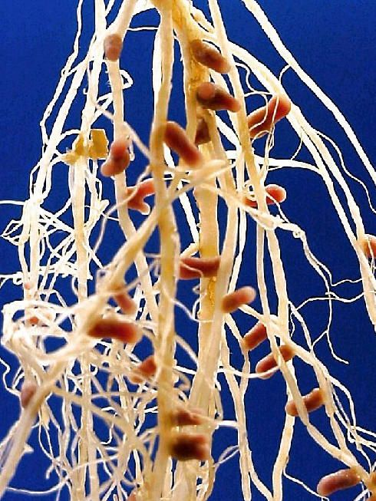
Nitrogen-fixing bacteria are microorganisms that arecapable of transforming atmospheric nitrogen into fixed nitrogen, inorganic compounds usable by plants. More than 90 percent of all nitrogen fixation is effected by them. Two kinds of nitrogen fixers are recognized: free-living (non-symbiotic) bacteria, including the cyanobacteria (or blue-green algae) Anabaena and Nostoc and symbiotic bacteria such as Rhizobium, associated with legumes (e.g., alfalfa, beans, clovers, peas, soybeans) and “cereal” grasses.

The symbiotic nitrogen-fixing bacteria invade the root hairs of host plants, where they multiply and stimulate formation of root nodules, enlargements of plant cells and bacteria in intimate association. Within the nodules the bacteria convert free nitrogen to nitrates, which the plant utilizes for its development. To insure sufficient nodule formation and optimum growth of legumes, seeds are usually inoculated with commercial cultures of appropriate Rhizobium species, especially in soils poor or lacking in the required bacterium. See also nitrogen cycle.
